DIVYARAJ.D
Mobile: +966-557569375
E-Mail: divyaraj.d.mba@gmail.com

MIDDLE MANAGEMENT PROFESSIONAL
Senior Terminal Planner (Vessel & Yard) / Operational Coordinator
Industry Preference; Shipping (Liner Operations); Location Preference; UAE, Canada, Australia or Anywhere

PROFILE SUMMARY
- A result oriented professional with nearly 6 years of experience in Vessel’s Operations & Management, Overall Administration on Board and Terminal Planning & Scheduling
- Competence in handling the yard operations; implementing quality parameters for service areas as per the standard and international guidelines
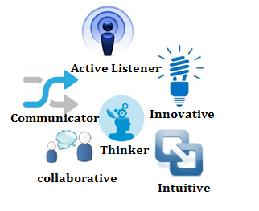
- Functional expertise in managing various formalities in documentation for clearing consignments; adept at devising and effectuating innovative strategies for ensuring safe, smooth, timely transportation of goods throughout country resulting in customer satisfaction
- Gathered fair understanding in navigation, passage planning, manpower planning and cost / time effectiveness
- Proven ability to interact easily with people of diverse backgrounds, motivate individuals to excel in the learning process and provide highest level of service
- Demonstrated analytical, problem solving & organisational ability coupled with strong team building, communication and relationship management, with teams of multi-national crews

CORE COMPETENCIES
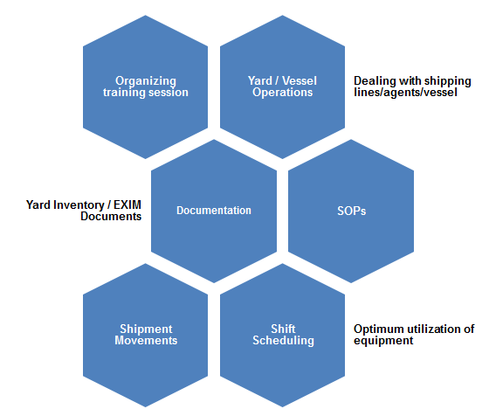
- Conducting briefing & de-briefing of each shift and updating staff on all operational matters including delays, disruptions and contingency planning
- Directing the activities of the airport to include overseeing the development and administration of policies, procedures, programs, goals and objectives
- Reviewing yard / vessel operations to determine the efficiency and effectiveness of services and/or programs; monitoring process of contracts; evaluates services performed and costs for services obtained through outside contractors and vendors
- Providing overall command of large ship routine, critical operations including arrival and departures from Ports, Rough Weather Navigation as well as involved in Watch-keeping during critical situations
- Effective liaisons with port, terminal & statutory authorities for quick turn around and completion of voyages, with nil or minimum claims for short-landings, weather damages or other similar causes
- Maintaining ship operations precisely as per the long term schedule, as instructed and advertised by the logistics team; Achieving quality targets by installing foolproof methods, providing training to officers and crew, developing & modifying skill sets

CAREER CONTOUR
Since Aug’13: National Container Terminal (KAP), Saudi Arabia as Terminal Planner (Vessel & Yard) & Operational Coordinator
KRAs;
- Ensuring:
  - Yard & vessel plans are prepared by Process Controllers; equipment (RTGs, TTS, and QCs) are optimally used as well as monitoring the IMDG cargo segregation in daily schedule
  - All mails of customers (internal and external) are attended and replied with company norms
  - Optimum utilization of equipment and resources to achieve in fuel consumption
- Dealing with shipping lines/agents/vessel whenever required for smooth operations
- Creating daily activities reports of yard and submitting the same to Operations Manager
- Organizing training session for new operator in terminal procedure, yard layout & terminal
- Working in close relation with Ship Superintendent & Supervisor - Yard & Wharf Controllers for smooth operation at vessel & yard site operations
- Reporting to GM - Operations regarding the development in the terminal entailing number of moves performed at the quayside by each crane & any equipment breakdown
- Generating yard inventory documents and sharing it with the GM & Control Center on regular basis
- Overseeing export / import movement at the Gate & Yard; communicating system problems to all relevant parties i.e. SM, Section Head and IT Manager
- Active involved in external activities such as managing vehicle mounted terminal (PDA) device, participating in physical activities in yard
Mar’10-Aug’13: Maersk Global Service Centres as SME Specialist (Inland & Vessel Operations)

KRAs;
- Shouldered responsibilities as:
  - Focal from GSC side for the migrations
  - Process Lead for the knowledge sharing process between the country clusters and GSC team
  - RKEM super user to resolve the system issue, activate and deactivate the units in RKEM
- Validated the SOPs with country operations for the process been migrated to GSC
- Controlled the performance of team members to ensure efficiency in process operations and meeting of individual & group targets; held accountable for managing Asia Pacific Operations and Central American Clusters
- Handled process like Intermodal (Allocation of Containers thru Truck, Rail & Barge), Cost Control Project and Equipment (Supply & Demand, Longstanding Containers Equipment Off-hires, Aligning the Sequence of Moves in the System)
- Conducted huddle session and updated the team with the latest information; monthly discussion with team members on performance and provided constructive feedback and support to improvement.

Attainments;
- Bagged MAERSK Performance Excellence Award, 4 times by achieving and maintaining the accuracy level at 99.00%

KNOWLEDGE PURVIEW

- OPUS Terminal Operation System powered by CyberLogitec, Korea
- Maersk Systems - RKEM, GCSS, GLEO, GSIS, RCA and MARVEL

EDUCATIONAL CREDENTIALS

Bachelors in Business Administration in 2009
St. Thomas College of Art & Science, University of Madras, Chennai
Awarded as First Grade in Business Administration Subject

Diploma in Computerized Hardware
Certified by Personal VUE Groups, UK

IT Skills: Conversant with Windows 2000, XP & Vista; MS Office; Computer Hardware and Typing Speed

PERSONAL DOSSIER

Date of Birth: 22nd July, 1989
Permanent Address: 6, Pillayar Koil Street, Madhuravoyal, Chennai – 600 095
Nationality: Indian
Marital Status: Single
Passport Details: H2537216 (Valid Up to: 09/02/2019)

Please refer to attached annexure for project details:

ANNEXURE
Clients | Reliance insurance (College project) | Maersk Global Service ltd | National Container Terminal (King Abdullah Port)
Platform | Employee Satisfaction | Process performance improvement | Empty containers depot management
Languages & tools Used | Statically tools and pivot table | RCA tools & data analysis method | Flow chart and data analysis
Responsibilities | Collect the feedback form from employees and make report with the collected data | Collect past data and analysis the root cause for process improvement | Forecasting the empty flow INBOUND & OUT BOUND containers. GATE inward & outward empty containers
Description of the Project | Find the job satisfaction level of employee. Finding out cause for down performance in process and suggestion to implementing some change in process | Reduce the NON-VALUE ADDED in process and create SOP. Implement new tools for process simplification | Have prepared the yard allocation to divide the empty for T/L loading and Empty Pickup. And also use minimum equipment for OUTBOUND in effective manner
Location | Chennai (India) | Chennai (India) | Saudi Arabia
Duration | 3 months | 6 months | 6 months
Team Size | 3 person | 12 person | 1 person

