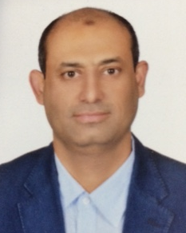
Personal Data:

Name : Samir Mohamad Kamel Rabia
Date of Birth : January 23rd , 1969
Address : Al-Sadd Street – Doha - Qatar.
Mobile (Qatar) : +974/55567167
E-Mail : samirrabia@msn.com
Marital Status : Married
Driving License : Egyptian – Qatari: Both are valid
Passport : valid up to 15/08/2019

Education:

Graduation : B.Sc. of Mechanical Power Engineering – Faculty of Engineering
University : Alexandria University
Year : 1991
Degree : Good

Computer Skills
MS Office - PRIMAVERA – AUTOCAD

Membership
Qatar Engineers & Consulting Offices Accrediting Committee of (UPDA) – Grade (A) Mechanical Engineer.

Courses
- MICA Project Management Course
- Training of Trainer Course (TOT)
- LEED GA Course
- Introduction to Autodesk Revit 2014.

Languages

- Arabic; mother tongue.
- English; very good reading, writing & speaking.
- German; fair reading, writing & speaking.

Key Qualifications:

- Worked in contracting companies for more than seventeen years in various positions both site and office based.
- Worked in consulting firms for five years as a senior supervision engineer.
- Demonstrate in-depth knowledge through the ability to resolve complex issues.
- Demonstrate knowledge of disciplines beyond own area of specialty, and keep up-to-date with leading edge developments.
- Execute work independently and provides guidance to others.
- Have a very good knowledge in contract administration including variations, cost and time claims and arbitration and site management.
- Very familiar with all applicable International Codes & Standards such as ASHRAE, BS, EN, DIN, ASTM, ANSI, NFPA, UL, FM, LPCB, QCS, etc.

Accomplishment over My Professional Life:

- Obtaining Client & Consultant's approval to replace the specified expensive Polyethylene Silent Drainage Piping with Polypropylene Low Noise Piping saving material and workmanship costs, time for installation, welding machine costs and skilled labors.
- Design review of air conditioning and ventilation system in Chemical Laboratories to accommodate the required Chemical Fume Hoods using VAV system instead of CAV system, keeping the Energy Management System efficient.
- Preparation of many successful E.O.T and cost claims such as Extension of time and additional cost due to working on the new roads, Applying contract fluctuation equation to the supply of pipes and fittings BOQ, Additional costs due to prolonged transportation of pipes from the owner's stores to the work sites, etc.
- Discover the defects in the A/C compressors vibration isolators and replacing the defected units (1200 nos.)by the manufacturer.
- Discover the Microbiological Influenced Corrosion (MIC) attacking the Stainless Steel 316 piping and replacing it with PP-R piping inside the BAYTI Dairy Factory during commissioning the water treatment plant.

Main Responsibilities along My Career:

- Responsible for Fire Fighting (Sprinkler System, FM-200 & Foam Suppression Systems), HVAC (District Cooling, Energy Management System and Laboratories' Controls), Plumbing, Drainage (Grey Water Treatment Plant) and Irrigation services.
- Leading team of mechanical engineers and inspectors.
- Review the IFC drawings, BOQ and specification for constructability prior to start work.
- Review Contractor’s mechanical services shop drawings, in compliance with IFC drawings, project specification and applicable codes and standards.
- Review and process all mechanical material submittals and samples for compliance with the project specifications and the applicable codes and standards.
- Review contractor’s correspondence related to mechanical works and draft appropriate response.
- Process Mechanical Request for Information (RFI). Discuss RFI’s requiring design feedback with the Designer for response.
- Liaise on a technical basis with the Projects Managers.
- Attend weekly, monthly and other progress/technical meetings.
- Review the progress reports. Identify constraints and recommend corrective measures.
- Liaising with governmental authorities (Drainage Department – ASHGHAL - KAHRAMAA – Civil Defense Department - Qatar Cool) to obtain work permits and apply for city services connections including preparing drawings and documents required and attending the coordination meetings.
- Ensuring all material used and work performed conform to contract specifications, local standards and bylaws and applicable International Standards.
- Obtain material approvals from Project Consultant.
- Respond to consultant’s comments on shop drawings, material submittals and site NCR’s.
- Coordinate the flow of technical documents (requisitions, data books, drawings, specifications, calculations) between project operations, engineering disciplines, and other related support groups.
- Establish and maintain files and computerized indexes for active engineering documents.
- Generate technical/progress reports as needed by the project or management.
- Serve as engineering coordination job leader, providing technical guidance to Engineering Aides as required.
- Monitor and evaluate the performance and site attendance of Mechanical Engineers.
- Coordinate and report to the design team and Architects of discrepancies/missing details and information in design drawings and specifications.
- Witness site and factory inspections in ongoing installation works to ensure that the execution of Mechanical Works/Installations is in compliance with contract drawings, specifications, and Local Authorities regulations.
- Resolving any unexpected technical difficulties, and other problems that may arise.
- Attend meetings with Client and Sub-Contractors to resolve and propose technical and contractual solutions for any outstanding/disputed issues.
- Prepare and update the weekly material procurement schedules and the status of material submittals.
- Assign and audit the material take off to Mechanical Engineers for the purpose of material procurement.
- Manage the MEP subcontractors.
- Provide input to MEP subcontractors’ payment applications.
- Review all Engineer’s instructions for compatibility with Contract Conditions and advise on time and cost impact.
- Review contractor’s mechanical change order proposals and prepare recommendations to Project Manager. Assist in negotiations with contractors regarding changes in contract value or project duration.
- Witness testing and commissioning of all mechanical works.
- Review/approve the contractors’ as-built drawings and O&M manual submittals.
- Supervising fabrication, painting and testing of 2*40m³ steel fuel oil tanks.
- Preparation of prices breakdown for variation orders.

Career History:
- Senior Mechanical Engineer February 2016: Till date
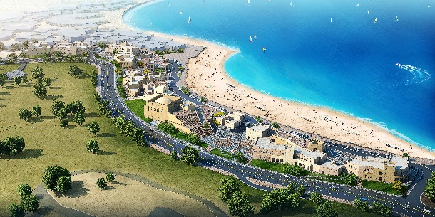
In Boom General Contractors (Qatar) www.bgcqatar.com - Grade (A) Main Contractor – In KATARA South Plaza Building, a project to construct 11 Restaurant & Day Hotel buildings and Planetarium Building with one common basement with 50,600 m² Built Area.

- Senior Mechanical Engineer May 2014: January 2016
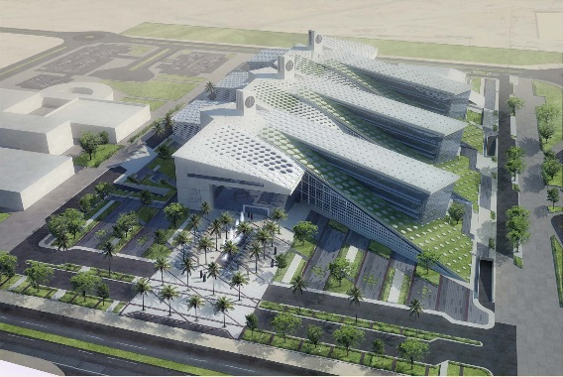
In Katib & Alami (QATAR) www.katibalami.com –big consulting firm- Involved in the following projects:
- Construction of New College of Engineering – Qatar University.
- VB-26 Residential Tower (B+G+M+23) in PEARL Qatar.
- 2 Daily Mosque Buildings in PEARL Qatar.

- Mechanical Project Manager March 2013: April 2014
In ATHAR Building & Development Co. (Qatar) www.athar.qa , Mechanical Subcontractor for AMIRI Guard BARZAN Camp Phase II Project – A project to execute mechanical services in the 4 nos. Barracks Buildings including HVAC, Fire Fighting, Plumbing and Drainage services. Lead a team of 12 Mechanical Engineers, dealing with Client, Consultant, and Main Contractor. Represent the Mechanical Subcontractor in all progress and technical meetings to discuss key issue related to the project and take effective actions, ensuring the project is delivered on time and within budget. Ensure that the health and safety requirements are provided and that they comply with authorities’ regulations. Monitoring project budgets and schedule and oversee performance to ensure on time, quality and on budget project execution. Provide guidance, managerial, technical support to complete project team. Read & analyze drawings, specifications and statements of work in the preparation of activity networks for project resource planning and scheduling. Prepare plans and schedules, status reports and performance evaluation. Provide program planning capabilities including interfaces and risk analysis. Establish and monitor program and project controls KPI’s. Ensure program policies and procedures are implemented accordingly. Develop action and recovery plans to support program delivery on time. Advise on technical issues related to Construction matters, in order to meet specific project requests. Ensure effective management & utilization of time for personnel.

- MEP Section Head May 2012: March 2013
I worked in A’AYAN AL-SHARQ Construction (Private Business) as an Executive partner responsible for MEP section acting as MEP subcontractor.

- Plumbing, Drainage and Fire Services Manager Feb 2010: April 2012
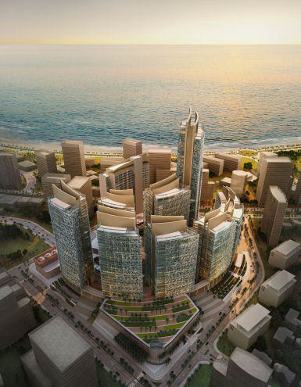
In BOUYGUES BATIMENT INTERNATIONAL (Qatar branch) www.bouygues-construction.com, worked in QP Financial District Project owned by Qatar Petroleum and supervised by KEO Consultants;700.000 m² GBA of an integrated financial district (10 towers; 9 offices and one five stars hotel and a conference center, Shopping mall and the related amenities.
I was responsible for procurement, subcontracts and all technical affairs for Plumbing, Drainage, and Fire Fighting works from Contractor’s side.

- Senior Mechanical Engineer Apr 2009: Feb 2010
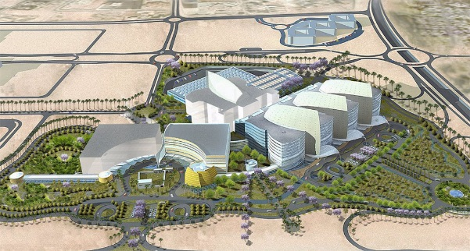
In CONTRACK Cyprus Limited (Qatar branch) www.contrack.com Work in SIDRA Medical & research Center project owned by Qatar Foundation.
Responsible for Plumbing, Drainage, Chemical Waste, Steam, LPG, Fire Fighting and Medical Gases systems in Hospital and Out Patient Clinic Buildings in both site works & technical office works. VOLTAS is the Mechanical Sub-Contractor and under supervision of KEO Consultants.

- MEP Coordinator Oct 2007: Apr 2009
In ALDARWISH Engineering (QATAR) www.aldarwisheng-qatar.com-a major Qatari grade (A) construction company- working in the following projects:
- NEW DOHA INTERNATIONAL AIRPORT Project (NDIA)– Consultant is Overseas BECHTEL Inc. as a senior design review engineer (contractor’s side), responsible for reviewing all Fire Fighting (Sprinkler & Special Fire Suppression Systems), Plumbing & Drainage design drawings of CP-11 (Emiri Hangers and Air Lines Support Facilities) and CP-26 (Aircraft Maintenance Hanger)to ensure the compliance with the applicable local and international standards.
- AL-RAYYAN Residential Tower (2B+G+33) Project. Consultant is GHD Responsible for MEP works coordination and following up the MEP subcontractor.
- AL-REFAA Residential Tower (2B+G+M+32) Project. Consultant is GHD
Responsible for MEP works coordination and following up the MEP subcontractor.
- TIVOLY Show Room Project, Consultant is Gulf Design Concept GDC.
Responsible for MEP works coordination and following up the MEP subcontractor.

- Senior Mechanical Engineer Jan 2005: Oct 2007
In Arab Engineering Bureau (AEB QATAR) www.aeb-qatar.com –big consulting firm- Involved in the following projects:
- Al-Mirqab offices Tower (B+G+M+23).
- Al-JASIM Group offices & showroom building (B+G+M+15).
- ALI BIN ALI Group headquarters office building (B+G+11).
- Al-FARDAN Gardens II - construction of villas compound consists of 142 (G+1) villas, (B+G+1) club house, R/O plant & 17 swimming pools.
- HAYA Residential & Office Compound – construction of 11(B+G+3) residential buildings, one (B+G+2) office building &(G+1) club house.
- ARACO Showroom & Workshop – construction of VOLVO heavy equipment and trucks showroom & workshop.
- Construction of new BMW Automobiles workshop.
- Construction of Spectator’s Stand for Camel Race Track (Owner is Public Works Authority – ASHGAL).
- Construction of new Studio for Newsroom at Al-Jazeera Satellite Channel.
- Construction of 5Nos.residential & office high rise buildings.
- Construction of Gulf Times Newspaper New Offices.
- Construction of many villas compounds.
- Refurbishment & fit out of Alrayyan Bank headquarters.

- Senior Mechanical Engineer June 2001: June 2004
In GINZA for construction and real estate Co.www.igi.com.eg(an Egyptian ISO certified grade - A- contracting company) involved in:
- Construction of IGI INTERAGRO DAIRY PLANT PROJECT in NUBARIYA “Bayti milk factory”. An EPC contract from 02.06.2001 till 31.10.2003. Process equipment supplied and installed by GEA Process Technologies – Ireland. I was responsible for installation and commissioning of steam, condensed water (pumped and gravity), fuel oil, compressed air, treated water, chilled water, plumbing, cooling water, effluent, foul &firefighting systems. Total amount of Electro-mechanical works is US$30 million. I prepared variation orders and claims related to mechanical works such as claim for extension of time and additional costs due to delay of P&ID of the process.
- Tendering department from 01.11.2003 till 20.06.2004 responsible for mechanical works estimation including materials take off required for tenders.

- Head of Technical Office Apr1998: May 2000
In UNITED ENGINEERS Co. FOR FOUNDATIONS & CONSTRUCTIONS.
Main Contractor Worked in the following projects:
  - Construction of AL-IMAN Prep School at ABUEL-MATAMEER Town.
  - Construction of EL-NOUR Religious Institute at ABUEL-MATAMEER Town. Responsible for water supply, sanitary drainage and firefighting works.

- Head of Technical Office Apr1993: Sep1997
In the CO-OPERATIVE SOCIETY FOR PRODUCTION, BUILDING & ERECTION the main contractor of project #9A to install potable water pipelines in KAFR EL-DAWAR & NUBARIA –a major world bank funded project- to rehabilitate, upgrade and extend the water supply facilities for the whole of BEHEIRA Governorate - EGYPT. Responsible for preparing cost and time claims and arbitration documents, monthly statements, variation orders, review shop drawings, obtaining governmental work permissions, Liaising with the Client (national organization of potable water and sanitary drainage) and the consultant (Binnie Taylor Egypt in association with Dr. Ahmed Abdel-Warith), procurement and stores sector, sub-contractors monthly invoices, liaising with client / consultant on invoicing issues. This project was to install 135km DCI pipelines of various diameters ranged from 100mm up to 1000mm including supply of all related valves and fittings. Total amount of the project was US$7.5million. I prepared variation orders for:
- DN1000mm ductile cast iron twin raw water pipelines for NUBARIYA water treatment plant from intake point to the plant location (1800m).
- DN900&300mm ductile cast iron pipelines of filters backwash from KAFR El-DAWAR water treatment plant to the drain point (3500m).
- 8 Nos. steel trusses required for over canals pipelines crossings.
- 2 Nos. under high way pipelines crossings (DN500&400mm) at KAFR EL-DAWAR.
- 2 Nos. under railway pipeline crossings (DN700&400mm) at KAFR EL-DAWAR.
- DN400mm under canal crossing at KAFR EL-DAWAR.

