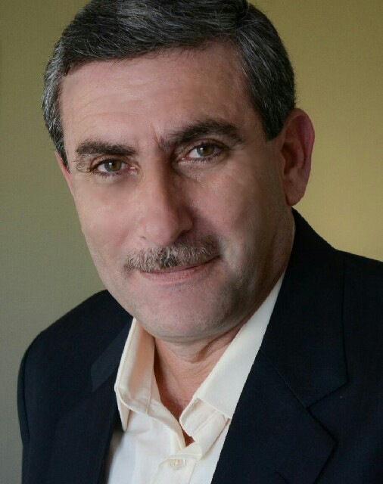
Ismail ElAchkar CV
B. Sc. Civil Engineer
Contact:
SAUDI ARABIA-Riyadh-Mobile: +966 5678 33244
iashkar@yahoo.com
https://www.linkedin.com/in/ismail-achkar-2bb9ab36/2bb9ab36/

Additional Qualification
Project manager with 20 years’ experience in various fields of Civil Engineering:
- Construction of Water Pump Station with Strategic Steel Tanks, Site Development & Infrastructures, Saudi Arabia.
- Certified by ABB Group: Project &Site Manager for 8 years in construction of Substations& Gas Lines, Roads, and Industrial& Precast buildings, Saudi Arabia.

Interests
- Art and Humanities
- Literature
- Fine Arts
- Photography

ABB Professional Training
- Communication Skills (Apr. 2014) Riyadh.
- Project Safety management (Feb.2013) Khobar.
- Project safety management (2010) Khobar
- Setting Priority, Time Management & Stress Management (2010) Riyadh.
- Project safety management (2008) Khobar
- Project safety management (2007), Khobar
Educational Qualification
B.Sc. from Damascus University / Faculty of Civil Engineering /1985
- Practical Experience in Saudi Arabia (2003 up to date)
Organization 1 | UNITED for Civil Constructions – Riyadh ( 21-Dec. 2014- 2018)
Designation & Project’s Description | - Project Manager: Construction of Water Pump Station with Two Strategic Steel tanks (80meters/Diameter, 16 meter height) with related Lines &Buildings, Al Baha Area. Client: National Water Company.  - Projects Manager: Construction Two Building’s projects (Social Protection Unit & Guest House) of new eight buildings with total building area of 13,630 m2, Geo-technical, Construction& Finishing, Sites Development including infrastructure, Riyadh. Client: Ministry of Social Affairs.

Organization 2 | ABB Group (Oct.-2006 to Dec. 2014)
1. Duration-ABB | 21-May 2013 up to 20 Dec. 2014
Designation & Project’s Description | Projects Manager: Construction& finishing of new Three Sub-Stations, included of GIS & Control Precast buildings and Gantry area connected with Transmission Lines, at Abha, Jezan& Najran. Client: Saudi NG
2.Duration-ABB | 01-August 2012 to 20- May 2013
Designation & Project’s Description | Project Manager: Construction& finishing of Jubail Sub-Station, included of GIS & Control Precast buildings and Gantry area connected with Transmission Lines, at Dammam- Jubail. Client: Saudi Electricity Company/NG
3.Duration-ABB | 01- Nov.2010- to Jan.2011
Designation & Project’s Description | Project Manager: Construction& finishing of Al-Fakhriyah Sub-Station, included of GIS & Control buildings and Gantry area connected with Transmission Lines, at Dammam. Client: Saudi Electricity Company
4.Duration-ABB | 01-June 2009 to 31 Oct. 2010
Designation & Project’s Description | Project Manager: Construction& finishing of Qurayyah Sub-Station, included of GIS & Control Precast buildings, Gantry area connected with Transmission Lines and Gas Insulated Lines, at Al Khobar. Client: Saudi Electricity Company
5.Duration-ABB | 01-Aug. 2008 to 30 May-2009
Designation & Project’s Description | Senior Site Manager: Construction& finishing Extension of Two Sub-Stations Sakaka A& B, included of Control buildings and Gantry area, at Sakaka. Client: Saudi Electricity Company
6.Duration- ABB | 01-Feb.2007 to 31 July-2008
Designation & Project’s Description | Senior Site Manager: Construction of Two Sub-Station (Qurayyah& Half-moon), included of GIS & Control buildings and Gantry area connected with Transmission Lines and Gas Insulated Lines Station, at Al Khobar. Client: Saudi Electricity Company.
7.Duration -ABB | 01-Oct.2006 to 31 Jan-2007
Designation & Project’s Description | Site Manager: Geotechnical works, Construction& Finishing Sub-Station (Ahad Al-Masaarha), included of GIS & Control buildings and Gantry area, at Jezan. Client: Saudi Electricity Company

Organization 3 | SELCOP – Saudi Electrical Contracting Co. (Feb. 2003 to 30 Sept. 2006)
Designation & Project’s Description | Regional Manager: Leading the projects for Civil Designing and Execution work of Electrical Distribution Lines and Transformers with Related Civil works, at Assir, Tehama & Bisha Areas. Client: Saudi Electricity Company.
Responsibilities in the projects mentioned above
- To manage Construction& Infrastructures activities at all stages of the project.
- To manage project schedule to all participants of the project.
- Progress Monitoring and Progress reporting to Client/Consultant as well as to Company Management.
- To manage Procurement schedules and monitor procurement progress for prompt delivery of materials and supplies.
- To ensure that the Safety requirements are carried out in compliance with Company and Client standards.
- To organize required quality& inspections by Client/Consultant and maintain proper record of Quality verification documents.

- Practical Experience in Syria:
Organization 4 | Al Rayan Engineering Office (May 1993 to Jan. 2003)
Designation & Project’s Description | Owner & Director of my Office, Civil designing/Consulting and Execution for various types of Buildings and Schools Including Different Contracting works.
Organization 5 | DIRECTORATE OF National TECHNICAL SERVICES (1985 to 1993)
Designation & Project’s Description | Project Engineer, Construction& Finishing Activities for different projects in Syria: Hospitals Buildings, Schools, Roads, Bridges & AL ZOLOF Dam at all stages, and Preparing Technical Specifications and Breakdown Lists.
Computer Literacy: | - MS Project  - MS Office (Word, Excel)  - AutoCAD.  - ABB Pirs. (Project Information Retrieval System) and Lotus Notes.
Personal Profile: | Place& Date of birth : Venezuela, 1959  Nationality: Syria, Venezuela  Permanent resident in: Saudi Arabia  Status : Married
Professional References: | 1). Mr. Ali Al-Khairi, Saudi Arabia – NG- Transmission, Overall Projects Manager, (Mob: 0500405511)  2) Mr. Winston Gianella, BAHRAIN – ABB Project Manager, (Mob:039956733)

Kind Regards...

