Federico Lipparoni

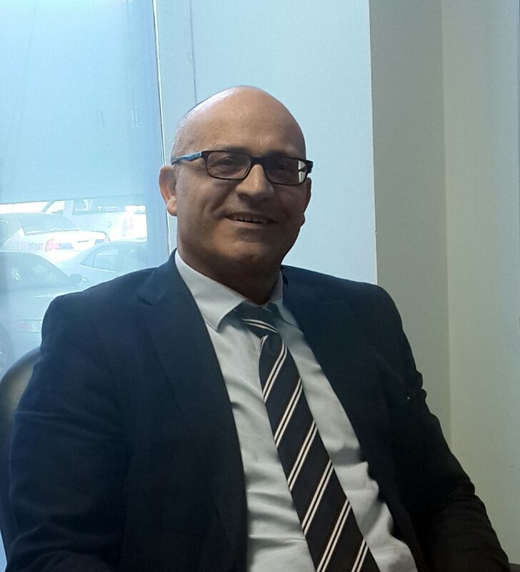

Terraces of Juffair, Road 2468, Block 324, Bldg 4669.
Manama, Kingdom of Bahrain.

Tel : +97339774210,+966537484462
Skype ID: federico.lipparoni1

TERTIARY QUALIFICATIONS

Matriculation Exemption:
G. Alessi High School, Perugia, Italy.

Degree in Architecture, 1991
University of Florence, Italy

Memberships:
Member of the Italian Board of Architects, 1992-2012.

Aspiring towards scaling heights in Architectural Design Projects in a competitive environment.

30 years of extensive experience in design architecture, project management, including resource utilization and team management. Competent in planning and cost effectively completing architectural projects starting from landscape design to towns and buildings. Skilled at providing technical support and developing new processes through ongoing, monitoring, defect determination and improvement solutions. Expert in completing projects within crucial timelines and budgets. Strong technical and methodical aptitude with ability to create, analyze and coordinate data.

Accomplishments

Design Architecture:

- Spearheaded cost effective architectural design projects with in-depth knowledge of antique principles such as: mass, volume, texture, environment, climate, space, materials and codes landscape, space concepts and pragmatic elements like cost, construction and technology.
- Recognized for cost effective planning and architectural designing of landscapes, towns and buildings particularly using AutoCAD 2D, Sketch Up and Hand Drawings as well.
- Knowledge electrical systems for architectural projects including designing electrical layout, managing plumbing plans, heating and AC requirements.

Project Management:

- Managed and organized project operations and personnel, strategic plan development, forecasting and architectural plan implementation.
- Prepared & implemented strategies streamlining existing work-flows in order to increase efficiency.
- Initiated reporting for both the design and construction of built environment as required.
- Liaised with consultants and building officials to bring projects to their successful conclusion
- Took corrective action by directing changes in project activities or, in some cases, coordinating the revision of project plans.
- Built long-term client relationships to efficiently and effectively meet business objectives.

Contract Management:

- Created and maintained schedules utilizing methods that best suited the scope and complexity of individual projects.
- Reviewed bids, negotiated contracts and purchase orders and periodically tracked costs and revenues in a manner consistent with keeping project budgets within predetermined limitations.
- Established necessary relationships with city officials in order to secure building permits for a variety of projects.
- Carried out assignments of engineers and support staff, coordination with clients, consultants, subcontractor and suppliers, control of material procurement.
- Oversaw on-site repair and maintenance workshops for equipment utilized on site.

Quality Management

- Delivered outputs to the highest possible standards and monitored all areas involved, ensuring that all tasks were completed accurately.
- Regularly monitors and determines if the project is being executed in a manner indicating that the work, when completed, will be in accordance with the contract documents.

Employment History:

- Senior Design Manager / Archen Engineering, Saudi Arabia : April 2015 to Present
Seconded to MOI (Ministry of Interior Technical team)

My Duties include the following:

- Architectural/Interior concept design of infrastructure master plan, mixed use residential / hospitality / offices / guards training center, Bahrain, KSA.
- Projects size varies from : 20,000 SQM to 8,000,000 SQM
- Managing multidisciplinary team: Architecture, infrastructure, civil, electrical, mechanical, communications and contract.
- Concept Design.
- Design development and documentation co-ordination
- Materials & Vendors selection
- Progress, budgeting, project control, site supervision.
- Coordination with the parties involved in

Notable clients and projects, include the following:

- Infrastructure development design of MOI Mega Sites, KSA 2016/18
- KSA National archive Buildings, KSA 2017
- Construction of a New Helipad, KSA 2016/2018
- Interior Design of the Exhibition Center, KSA 2017
- Renovation of VIP offices, KSA 2017/2018
- Rehabilitation of Command and control Center, KSA 2017
- New Penitentiary Program, KSA 2016
- Training city KSA, 2016
- Maritime Modernization Program, KSA. 2015
- Training Center conceptual Master planning, KSA. 2015
- Office Buildings , KSA.2015
- Health care center, KSA.2016
- Infrastructure Conceptual Master planning, KSA. 2016
- Helipad complex, Conceptual, DD,PMO, KSA.2016
- Infrastructure Conceptual Master planning, KSA. 2016

- Senior Design director / Jacobs Zate (Al Khobar – KSA) : June 2011 to March 2015

My Duties include the following:

- Concept design
- Design development and documentation co-ordination
- Material selection
- Progress, budget, project control
- Project management and site supervision
- Client liaisons

- Notable Clients and projects included in the following :

RasTanura Refinery, clean fuel and toluene, new extension.

- Project size : 100,000 SQM – New infrastructures, including several bridges, new security gates, control building, office building, utilities buildings, warehouses.
- Managing multidisciplinary team : Architecture, infrastructure, civil, electrical, mechanical, communications, RasTanura – KSA
- Started September 2014 – First design face completion June 2015.

Kaust New Student Housing

- King Abdul Aziz Science & Technology University
- Project Size : 200,000 SQM.
- Produced and managed Architectural / Interior design concepts
- Interface with Kaust engineering team and HOK Kaust Master plan Architects.
- Kaust – Jeddah – KSA
- Started October 2013 – first design face completion June 2014

Jacobszate headquarter building

- Al Khobar – KSA
- Project size : 25,000 SQM, G+12 Story building
- Produced and managed Architectural / Interior design concept and design development, material selection, site supervision quality team.
- Started October 2012 – completion September 2014

Saudi Aramco Science & Technology Exhibition Center

- ESC, Facelift – Detailed design phase,
- Project size : 5,000 SQM
- Managed detail design phase, Architectural and Interior design, project control and material selection
- Dharan – KSA
- Started December October 2013 – Completion May 2014

Saudi Aramco, Shaybah Border Camp

- Shaybah – KSA
- Project Size : 15,000 SQM (Admin buildings, soldier dormitory buildings, ammunition warehouse, kitchen / dining building, GYM and recreational building, mosque, fuel station.
- Produced & managed architecture / interior design concept, material selection.
- Started February 2013 – completion July 2013

Saudi Aramco, Shaybah Wild Life Sanctuary

- Shaybah – KSA
- Project Size : 10,0000 SQM, Museum, visitor center, animal rescue center, veterinary, warehouse, fuel staion.
- Produced & Managed Architectural / Interior Design concept, material selection.
- Started December 2012 – completion July 2013

Saudi Aramco Science & Technology

- ESC, Facelift – Renovation concept design
- Project Size : 5,000 SQM, managed architecture / interior design concept
- Dharan – KSA
- Started December / January 2013 – completion April 2013

HufHuf Health Center Renovation

- Al Hasa – KSA
- Project Size : 25,000 SQM
- Produced & Managed Interior design concept, schematic, detail design, material selection, vendors acquisition.
- Started December 2011 – Completion May 2013

Saudi Aramco Juaymah Gas Plant - Juaymah new administration building

- Juaymah –KSA
- Project Size : 5,000 SQM
- Produced & managed interior design concept, schematic design, material selection, vendors acquisition.
- Started March 2012 – Completion October 2012

- Senior Architect / Project Manager (Plan + Architecture & Design), Bahrain : May 2008 to May 2011

My Duties include the following :

- Concept design
- Design development and documentation co-ordination
- Material selection
- Progress, budget, project control
- Site supervision
- Client liaisons
- Contract documentation compilation
- Tender document compilation
- Contractor selection
- Procurement

- Notable Clients and projects included in the following :

Mr. Bader Hasan

- Private Villa in Tala Island, Bahrain.
- Project size 1600 SQM
- Produced and managed concept design, schematic design, material selection, procurement assistance.
- Started March 2011 – Completed July 2011

Kazerooni Contracting Company

- Villas compound Amawj Island, Bahrain
- Project Size : 6,000 SQM
- Produced and managed concept design, design development, material selection, suppliers selection, site supervision for 9 villas in Amawj
- Started May 2011 – Completed December 2012

Mr.Abdulla Al Ali Office at Platinum Tower – Seef, Bahrain

- Office interior fitout
- Project size : 650 SQM
- Produced and managed concept design, detail design, project management, site supervision
- Started January 2011 – Expected completion January 2012

Dr.NayefLouri Private Villa in Sanad, Bahrain

- Project size : 1200 SQM
- Produced and managed concept design, design development, material selection, procurement assistance, project supervision.
- Started January 2011 – expected completion January 2012

Private Villa in Riffa, Bahrain

- Project size : 1800 SQM
- Produced and managed concept design, design development, material selection, procurement assistance, project manager for the whole fit out phase
- Started – April 2009 – Completed April 2011

Kazerooni Contracting Company, Bahrain

- Ten Villas Compound Saar, Bahrain
- Project size : 6500 SQM
- Produced and managed concept design (architecture and interior design), materials selection, suppliers selection, procurement assistance, site supervision
- Started August 2010 – Completed March 2011

HH Shaikha Haya Bint Rashid Al Khalifa, The Royal Court of Bahrain

- Project size : 2500 SQM
- Project Manager for the complete interior fit out of the new private villa of HH Shaikha Haya
- Started February 2010 – Completed March 2011

Kazerooni Contracting Company, Bahrain

- Three Private villas Amwaj Island
- Project size : 1500 SQM
- Produced and managed concept design, schematic design, materials selection, suppliers selection, site supervision
- Started – October 2009 – completed March 2011

Private Villa in Riffa, Bahrain

- Project Manager for the fit out of new swimming pool, lounge, fitness, recreation area
- Started April 2009 – Completed April 2010

CristianLacroix retail shop at Moda Mall, Manama, Bahrain

- Produced and managed concept design, project manager for the complete fit out
- Started September 2009 – completed November 2009

HH Shaikha May Bint Mohammed Al Khalifa (Minister of Culture and Information)

- Produced and managed concept design, project manager for the Water Garden at ShaikhEbrahim Cultural CenterMuharraq, Bahrain
- Started November 2008 – Completed May 2009

Armani Casa Café at Al-Ahli Mall, Manama, Bahrain

- Project manager, site supervisor of the new retail space of Armani Casa and café
- Started May 2008 – completed January 2009

HH Shaikha May Bint Mohammed Al Khalifa

- Project manager, site supervisor for the complete fit out of the new auditorium in ShaikhEbrahim Cultural Center, Muharraq, Bahrain
- Started July 2008 – completed November 2008

- Architect / Project Manager at Laboratorio di Architettura Associates (Italy) : September 2002 to April 2008

My Duties include the following :

- To promote the company and search for clients
- Concept design
- Design development and documentation co-ordination
- Tender document compilation
- Local authority liaison, submissions, co-ordination and approvals
- Progress, project control and budget
- Contractor selection
- Material selections
- Procurement
- Client liaison
- Project planning

- Notable Clients and projects included in the following :

- Rucoline Spa (Prototype of shop corner, japan) 2007
- BorgofioriSrl (residential building, Italy) 2007/2008
- Dott. Filistrucchi (Farm House –Spa, Italy) 2007/2008
- Dott. Ghini Hotel (Restaurant, Park, Italy) 2007/2008
- Manrico Cashmere Inc. (Store, USA) 2007
- MinioSrl (Antique Borough, Italy) 2006
- Rucoline Spa (Shoe Store, Italy) 2003/2004
- Manrico Cashmere Inc. 2004/2005
- Dott. Ghini (Residential, Italy) 2004/2005
- Oska GMBH (Show room, Germany) 2004

- Architect / Project Manager at F.B International New York, USA : January 2001 to August 2002

Exhibitions organizer across USA

My Duties include the following :

- Liaise with the client
- Concept design
- Brand identity
- Progress, project control and budget
- Logistic
- Local authority liaison, submissions, co-ordination and approvals

- Architect / Project Manager, freelancer: November 1992 to September 2000

My Duties include the following :

- Concept design
- Design development and documentation co-ordination
- Contract document compilation
- Tender document compilation
- Local authority liaison, submissions, co-ordination and approvals
- Contractor selection
- Material selection
- Procurement
- Progress, budget and project control
- Site supervision
- Client liaison

- Notable Clients and projects included in the following :

Manifattura di Ponte Felcino, renovation of an old industrial complex (19th century)

- Project architect, responsible for the whole aspects of the project
- March 1998 to July 1999

ICON Health & Fitness, Paris branch office

- Project Manager :January 1997 to April 1998

Kandis&Kandiceman, Fashion showroom, Munich,Germany

- Project architect, site manager
- November 1992 to June 1997 ; February 1997 to June 1998

ICON Health & Fitness, Italy & France branch office

- Project manager
- Complete fit out
- February 1996 to July 1996

Maglificio di Marsciano, offices and production

- Project architect / site manager
- March 1994 to January 1995

Manrico Cashmere International, shops sites, Italy, France, USA and UK

- Handled planning of all details within the exhibitory realm in Italy, France, Germany, Spain and USA.

Key Achievements :

Spearheaded numerous projects across Italy, France, Germany and USA and showcase architectural excellence in designing layouts for various showrooms, hotels restaurants and banks.

Expertly handled activities related to smooth execution of projects involving planning, logistics management, budgeting

Handled planning of all details within the exhibitory realm in Italy, France, Germany, Spain and USA

Played pivotal role in the supervision and planning of all architectural details for a new manufacturing company in Ponte Felcino, Italy and for individual brands in Italy, France and USA.

Earlier Career Snapshot

- Architect Freelancer : February 1987 to June 1992

- Self established firm

Key Achievements :

Provided immense and effective support for various firms in organizing participation in trade shows across Italy and Europe

Successfully handled formulation and preparing layout of plans, overseeing logistics, installations, displays of furniture, etc

- Advertising Coordinator : January 1984 to July 1987

- A fashion clothing company, GHINEA SRL, Perugia, Italy
- Versace spa, Novara, Italy

Acquire exposure working as a wall painter, carpenter and electrician during academic studies.

Key achievements :

Involved in coordinating with the president of the company and the sales director for formulating and executing the annual campaign, planned, organized and realized the seasonal defiles.

Conferred the responsibility of inaugurating a new showroom in Milan, Italy entailing duties like preparing a blueprint of the plan, searching for a construction enterprise and following up the work progress.

References

Arch. DavideChiaverini – PAD (Plan + Architectural & Design) – Managing Director
Manama – Kingdom of Bahrain; Tel +973 396 86156

e-mail : info@pad.bh

Dott.FrancescoGhini – Ghinea SRL – President
Perugia – Italy ;Tel +39 075 517 8743

e-mail : info@ghineasrl.it

Dott.ManricoCalzoni – Manrico Cashmere Inc – Chief Executive on Board
New York – USA; Tel +1 212 794 4200

e-mail : manrico@manrico.com

PORTFOLIO AVAILABLE UPON REQUEST

