Muhammad Nauman Akram
+97333472073
Nauman.akram@outlook.com
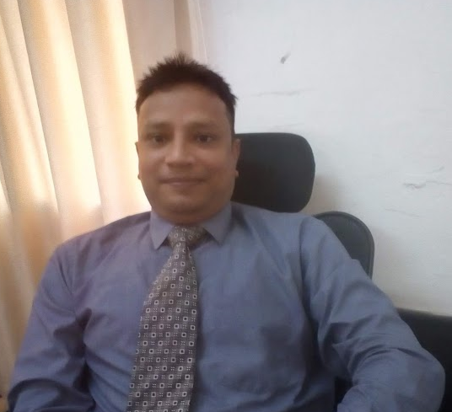

Summary
Certified Project Manager Professional (PMP) with 12 plus years of overall IT management experience. Ability to manage multiple large-scale projects, large teams of direct reports or cross functional teams with maturity and professionalism. Successfully completed numerous IT projects including web portal implementations, modernizations and migration projects; the development and implementation of n-tiered enterprise wide application development projects; ecommerce sites, datacenter infrastructure projects and datacenter migrations. Other implementations have included ERP, CRM, SaaS applications, web hosting applications, network migrations, large scale commercial data warehouses and online advertising systems. Proven track record of hands-on management and getting into the weeds to understand complex projects from the bottom up. Prefers Agile life cycle but understands every project has its own unique needs and objectives.

Professional Experience
Dotomatic Technologies Jan 2012 – Present
Project Manager
- Direct project team on creation of resource allocation planning, capacity planning, project scheduling, risk management and mitigation issues, action item resolution, performance requirements and productivity metrics tracking within a hybrid Agile and Waterfall environment.
- Created several team specific dashboards to provide a more accurate status to the stakeholders regarding project milestones.
- Managed Business Analysts to create Use Cases.
- Combined principals of rapid and joint application development to consolidate requirements gathering through joint approval meetings.
Tameer Micro Finance Bank Ltd (Branchless Banking) | Oct 2009 – Jan 2012
Manager O&M
- Facilitate project team meetings and work closely with Developers and business intelligence report writers to follow consistent configuration management procedures. Recommended and implemented the use of Version Manager for document and code control.
- To provide Project Management and coordination with vendor for development and deployment of AML solution for Tameer Bank
- To look after easypaisa (A joint venture of Telenor Pakistan & Tameer Bank) platform as key role member from inception for flexibility, performance, & daily operations with coordination of vendor, Technology, Financial Services System & Processes, Product teams, S&D, S&SC, CRD, Tameer Bank Back-end operation teams and also coordinating with Tameer technical team for easypaisa integrated systems flexibility & performance including Phoenix, IRIS, UBPS, KASB and different VAS Services.
- To involve & assist easypaisa UAT, QAT, Regression, Stress testing etc. with coordination of vendor, Technology, QA, Product & Services and business teams for all easypaisa increments with quality and timelines.
- To Develop and maintain easypaisa mobile accounts registration view for third party vendor and also develop and maintain registration status view for CRD.
BearingPoint Inc Management & Technology Consultants | Apr 2006 – Oct 2009
Technical Consultant
- To manage and look after easypaisa Financial Services Reporting Stream including Analysis, Design, Development, Implementation and operations for different stake holders including Telenor Product teams, Pricing and Business Planning, S&D, S&SC, CRD, Marketing, Fin-Ops, Treasury, Network Performance Analysis & Tameer Bank Fin-Con, Treasury, Business Intelligence, Back-end operations, Risk and Compliance etc. also reporting to SBP easypaisa Quarterly progress using MIS Portal, Schedule and Ad-hoc reporting.
- Managed successful completion of various local and international projects relating to ecommerce, core banking, mobile banking, group wide RFP's
- PTCL/ Etisalat - Human Capital Management. Served as Team Lead responsible for analyzing data and ensuring that data collection serves the organization’s strategic objectives.
- PTCL/ Etisalat - VSS Management. Acted as the Team Leader for development and analysis of VSS (Volunteer Separation Scheme) Software.
- Created a project plan and work schedule.
- Monitored and communicated project status.
- Gathered functional and non-functional requirements for the entire VSS. In charge with process acquisition, development and deployment of VSS software and operation of the call center.
- Vendor Evaluation for Zarai Taraqiati Bank(ZTBL) in Islamabad. Spearheaded team in vendor assessment, overall IT infrastructure review and RFP development for the bank.
Pakistan Ordnance factories | Jan 2004 – April 2006
Assistant Manager IT
- Managed and supported the implementation and deployment of all front-end, system administrative functions, and software change requests for two global software systems, for a global community of over 200 users.
- Supervised staff of four consultants for the continuing support and development of all production, enhancement and administrative issues on two global software systems.
- Maximized user acceptance and software reliability by reengineering front-end, back-end, reporting and scripting processes to increase user and support productivity by reducing cycle times while moving toward a Six Sigma Quality standard.
- Implemented and deployed a Change and Administrative Request System to help manage and monitor enhancement, production and administrative requests for two global software systems.
- Facilitated successful design, implementation and troubleshooting efforts with varying business and engineering disciplines including: Windows OS, UNIX, Security, Firewall, Database, Backups, EMC Storage, Monitoring, Application Engineering, Quality Assurance, Business Planning and Purchasing.
- Managed and troubleshot client network connectivity issues (Circuit, Router, Firewall and CPE Devices) to ensure full network application/database reliability through the frame relay and/or remote VPN connections.
- Responsible for developing high level deliverable schedule, estimates, detailed project plans and managing each team member to deliver the solution within a specified range of budgeted hours.
- Resolved conflicts in a diplomatic capacity between the product and implementation teams during product certification stalemates; manage all implementation and troubleshooting issues and project risks.
- Gathered and created final Client Operational Acceptance documentation and Signoffs; including network, OS and application troubleshooting guides; network diagrams; server, firewall, and database configuration sheets with start stop procedures, firewall and OS security scan authorizations.

Education
Project Management Institute (PMI) -- America | Oct 2010
Project Management Professional (PMP) PMP# 1364989
Hamdard University -- Islamabad | Dec 2002
Master of Science – Computer sciences
University of Punjab -- Lahore | Aug 1999
Bachelor of Science – Mathematics & Physics

Qualifications

- Excellent problem solving and deductive reasoning skills
- Ability to listen, see the big picture and resolve conflicts
- Excellent organizational ability with a high attention to detail
- Effective leader with strong interactive and interpersonal skills
- Innovative, creativity and a strategic thinker
- Capacity to make decisions and think on my feet
- Ability to work independently and as a team player

Technical Experience

- Front Office: Project, Excel, PowerPoint, Word, Outlook, Dreamweaver, Visio,
- Programming: PHP, SQL, .NET, VB, C++, Java, HTML, XML, JavaScript
- Databases: MySQL, SQL Server, Oracle, MS Access,
- Operating Systems: windows, Linux

INDUSTRY & BUSINESS PROCESS EXPOSURE

- Banking / Financial Services
- Internet / E-Commerce
- Human Resources
- Accounting / Finance

- Marketing / Sales Services
- Document Management
- Real Estate Services
- Utilities Services

APPLICATION SOFTWARE EXPOSURE
- Microsoft Project
- Microsoft Visio
- Rational RequisitePro
- Adobe Dreamweaver
- Embarcadero DBArtisan
- Rational ClearQuest
- Microsoft Dynamics Nav
- Microsoft SQL Server
- Rational ClearCase
- Oracle

PERSONAL CHARACTERISTICS
- Able to deal with either high-level business issues or technical details | - Creative, analytic problem solver that views issues from multiple angles
- Works well in team-oriented or independent environments | - Customer service-oriented

SKILLS & METHODS EXPOSURE
Project Planning Budgeting Issue & Risk Management Rational Unified Process (RUP)
Requirements Analysis Use Cases ER / Data Modeling Object-Oriented Analysis
Process Modeling Decision Support Change Management Business Process Re-engineering

