Curriculum Vitae **M**ohamed Abrar Faheem

**P**roject Manager

**D**oha ,State of Qatar.

**E**mail:faheem_abs@hotmail.com

**M**obile; +974-66593522

**P**hone ; +974-44436236

Having over 16 years of experience in Design,Coordination,Project Management, Interiors, fitouts, and Construction of a wide range of building types, many of them large and complex. I am well experienced and suited to working in new environments, successfully adapting to different cultures and work practices.

**Current Position**

Fitout Package Manager (Team lead), Qatar integrated railways project-Major Stations.

**Professional Affiliations:**

1**. Certified Grade ‘A’ from Ministry of Municipality and urban planning, Doha, State of qatar**

**2. LEED Green Associate ,GBCI.**

3. **Member of Council of Architecture, New Delhi India**.

NO: CA/2004/33233

**Courses attended:**

PMP (Project Management professional)

**Key Skills**

* Experienced in Large,high rise Building Projects & Interdisciplinary Coordination among the other Services of the building.
* Manage the guarantees of Fit-Out contractors in regards to defects
* Review Design Fit-Out Submittals (Concept & Detailed Design) and provide feedback to Clients
* Conduct regular on-site inspections of Fit-out installations as they progress through to completion.
* Periodically review the Logistics plan & update as the MDD site progresses.
* Review fit out design and ensure adherence to Local & International regulations and standards.
* Highly experienced in large size of interiors and fitout projects from scratch till the finishing. Projects involving various backgrounds such as ,Educational, hospitals, offices,highrise buildings, metro and stadiums.
* Experienced in procurement, reviewing specifications and selecting materials.
* Sound knowledge & huge experience in detail design drawings, conceptual and schematic drawings
* Identify opportunities for continuous improvement to enhance performance and quality of work with a view of stakeholders’ expectations.  
  Health, Safety & Environment
* Prepare organizational development plans and implement them throughtout the project.
* Highly experienced in defining/assigning the job responsibilities to the team.
* Experienced in high end architectural finishes, Wall, floor/ceiling
* Highly experienced in Carpentry joinery/wooden works
* Ability to Indentify the problems before they become critical & Formulate Practical solutions to the Architectural issues.
* Experienced in Proposing /Recommending the Building Material based on the concept & end users requirement.
* Experienced in Developing & Controlling large building projects through all the stages from Conceptual design to Commissioning & Completion.
* Experienced in Design & Construction works.
* Skilled at managing multiple tasks and competing demands
* Enjoys and works well in collaborative team environment.
* Experienced in Develop processes and policies
* Highly experience in snagging and completing them on time frame.
* Experienced in Site and Project Management.

**Professional Experience:**

**Consolidated Contractors Company from March 2007 to Present**

**Projects: 1- Fitout Package Manager**

**Qatar integrated Railway project Oct 2017 onwards.**

**Doha metro Major stations**

**Musherieb & Education**

First phase of the metro project is expected to be finished by 2019 in order to upgrade infrastructure ahead of the 2022 FIFA World Cup. The project include three new metro lines Red Line, Green Line & Gold Line, totaling a length of 86 kilometers, and 38 stations in Qatar's capital, Doha.

The major stations is a key part of the Doha Metro project. Msheireb is the central station, linking all three of the lines under construction during the project’s first phase (red, green and gold).

**Main Duties & Responsibilities**.

* Hands-on in monitoring the architectural works for conformance with the provisions of the contract documents and the procedures manual.
* Follow all relevant safety, quality and environmental management policies, procedures and controls to guarantee employee safety, legislative compliance, delivery of high quality products/services and a responsible environmental attitude.
* Coordination of interiors/fitout/FFE amoung various disciplines.
* Designed Master keying system for the both stations based on end users requirements
* Assigning tasks to the team and make sure are completed on time and are inline with local codes and design specifications.
* Coordinating with the Subcontractors/Vendors
* Participating in regular meetings with management, subcontractors & client representative.
* Attending workshop meetings, discussing issues and formulating practical solutions.



1. **Package Manager**

**Sidra Medical and Research Centre Sep 2015 to Sep 2017**

**MCJV**

**Total area**: 1580739

**Construction area**: 275140 Sqm

**Introduction**

Sidra Medical and Research Center will be  an ultramodern, all-digital academic medical center which will set new standards in patient care for women and children in Qatar, the Gulf region and internationally

**Main Duties & Responsibilities**

* Reviewing, and processing all shop drawings and architectural technical submittals
* Assigned to lead the package of interiors, fitouts, materials such as corian/ stone,cladding, Joinery and carpentry work.
* Monitor [sub] contractor’s performance in relation to acceptable standards.
* To ensure response to necessary construction documentation, Issuing, RFI’S
* Assign tasks to the Draftsmen , ensure to the met the deadlines
* Gain clear understanding of clients requirements
* Visit site regularly, implementing changes in methods & meeting with all involved project team
* Attending workshop meeting with client,
* Preparing documents for the QCDD approvals coordinating with the suppliers for the Certificates and approvals.

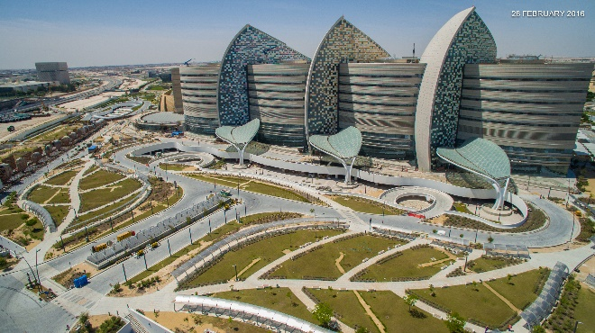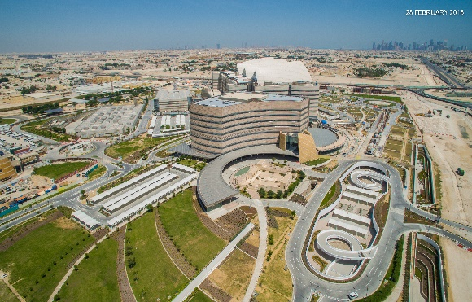

**3-Senior Design Engineer**

**Lusail Multipurpose hall**

**(Qatar Olympic committee, QOC)**

**Sep 2013 to Sep 2015**

Lusail multi purpose hall is located 25kms north of Doha, Its has been design to achieve atleast three stars under the Qatar sustainability assessment (QSAS) , The hall location is at lusail between shooting complex and the Racing club.Its consists of three buildings (Mutipurpose hall, Cooling tower building and Microwave Tower)

**Total area**: 387,123.4 Sqm

**Construction area**: 50,000 Sqm

**Design Architec**t : COX

**Structural Steel designer and skin** : Massimo Maffeis

**Architectural/ Engineering designer :** Dar al- Handasah

**Main Duties & Responsibilities**

* Review of preliminary project design concept, drawing & specifications
* Participating in regular meetings with Client, Consultants, Subcontractors
* Checking door and hardware schedule against the plans, Codes, Function, and MEP requirements.
* Preparing package related to fitout,interiors,FFE, specifications issuing to subcontractors For pricing.
* Daily site visits in order to check and verify the site are complying with shop drawings,Codes, Material submittals.

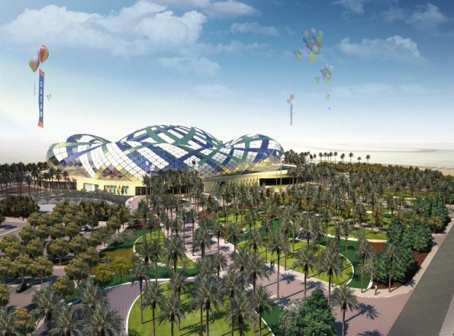 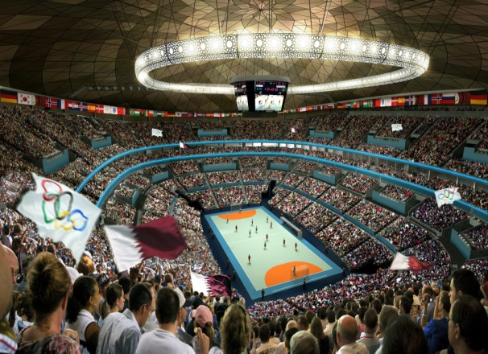

**4-Senior Architect.**

**Qatar Faculty of Islamic Studies Education city.**

**(Qatar Foundation, Doha, Qatar) July 2011 to Sep 2013**

Education city is a 2500 acre campus on the outskirts of Doha , Qatar which hosts branch campuses of some of the worlds leading universities , as well as numerous other educational & research institutions. Based on Masterplan by Arata Isozaki, MYAA & RHWL QF Representatives have commissioned for the design of the Qatar Faculty of Islamic Studies.

The Qatar Faculty of Islamic Studies ( QFIS) is located within the campus adjacent to the Dukhan Highway.The QFIS will be a faculty of distinction within an educational establishment of international renown & an an iconic facility which provides for Worshippers & Faculty.

**Construction area**: 35265 Sqm

**Design Architec**t : Mangera Yvar Architects , London

**Executive Architect : RHWL** limited , London.

**Consultant : ARUP** Doha , Qatar.

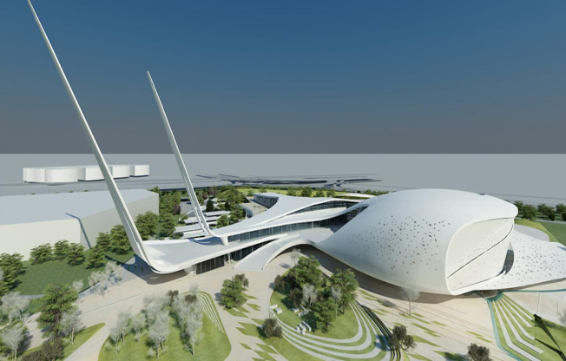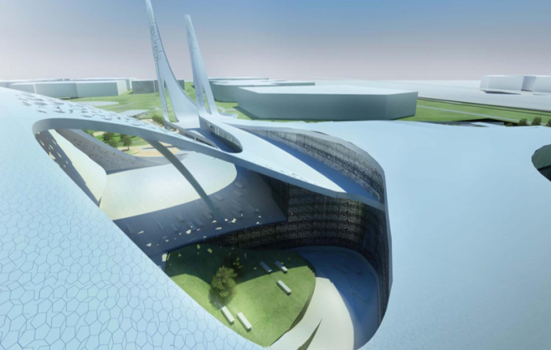

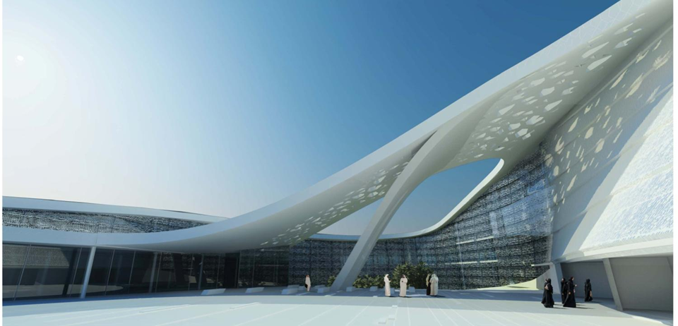

**Main Duties & Responsibilities**.

* Visited the door/hardware subcontractor Alkuhaimi Saudi arabia

For a factory visit and a meeting on board to finalise shop drawings and submittals

* Weekly visits to the Joinery subcontractor, to follow up the production,design and shop drawings submittals.
* Assigned as package manager of fitout related to all the wooden, joinery, wooden cladding tasking involving submittal of shop drawings, reviewing of design drawings, factory visits, site visits and material selection.
* To manage the efforts of the inspectors to ensure all documentation that is reviewed is than properly translated into a constructed product which meets requirements and specifications.
* Preparing GA drawings, coordinating among different disciplines.

**5- Architect**

**EPIC of Berths & Port Infrastructure for Ras laffan Port Expansion.**

**Raslaffan Industrial City Qatar.** **July 2009 to July 2011**

Ras laffan port expansion project (RLPEP) is located at Ras laffan industrial city (RLIC) located at about 80 Km north of doha.The scope of works includes Engineering, Procurement , Installation & construction of berths & port infrastructure .It has 90 buildings which includes Club, Acommodation & offices for Naval force Officers ,Medical Centre ,Security Monitoring centre , Telecom Buildings , Coastguard Base Building , Guard Houses & Substations.

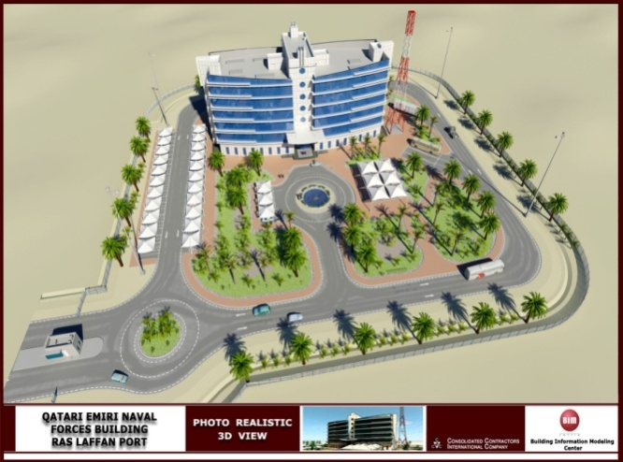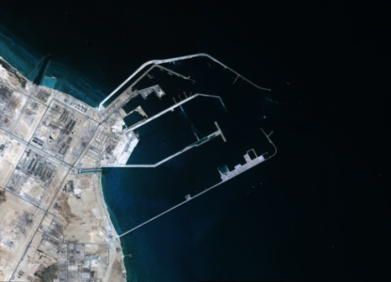

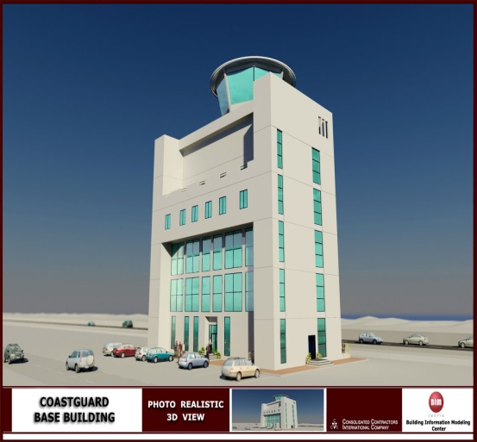

**5. Architect / Construction Support Coordination.**

**Carnegie Mellon Campus, For Education, Science, and**

**Development (Qatar Foundation, Doha, Qatar) March 2007 to July 2009**.

Project Area: Land area: 52750 m2 Construction area: 42000m2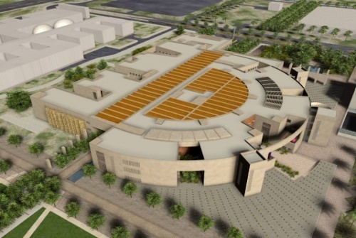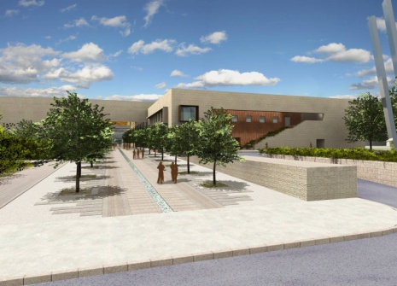

**Main Duties & Responsibilities**.

* Review of preliminary project design concept, drawing & specifications
* Following was handled

1. Doors/hardware
2. Complete interiors & FFE coordination
3. Wooden flooring/wooden cladding
4. PVC & rubber flooring.

* Visit site regularly, implementing changes in methods & meeting with all involved project team
* Prepare take off of architectural items.
* Preparing Red Mark & As built drawings .
* Give site backup on technical /design issues where required.
* Assist Head of Engineer in coordinating among all disciplines.
* Managing construction /implementation for conformity with approved design, including detailed scheduling, coordination & administration of construction changes.Issuing RFIS to the client/Consultants.

**Doha Asian Games Organizing Committee 2006(DAGOC) Doha , Qatar.**

**Overlay Architect and Site Venue Manager.**  July 2006 to Jan 31, 2007 (End of service)

Doha hosted the 15th Asian games 2006, where 10,000 athletes participated and officials from 45 countries.

As an **Overlay architect for Independent Training Venues and Doha golf club,** the following tasks were performed.

* Assist the Head of Venue Overlays in defining the responsibilities for the delivery of venues and establish working partnerships with relevant government agencies, venue owners, and private sector organisations.
* Prepare venue design briefs and project schedules for all venues in accordance with Doha asian games 2006 requirements and legacy requirements.
* Work closely with the Venue Operations team and other relevant Functional Areas in the Venue Planning process
* Assist in the develop of general overlay design and planning principles in conjunction with an overlay operating budget
* Assist in the develop venue specific temporary construction plans and comprehensive Event time overlay design briefs for all venue

As a **Site Venue Manager for Independent Training Venues**  the Following tasks were performed.

* Restoration of the venues to their Pre-Games condition.
* Coordinating with the contractors for the installation of the overlay works such as, temporary structures, portacabins, portaloos, blackouts , partitions & changing rooms.
* Manage overlay construction, installation, and preparation of identified venues and facilities for Event time use.
* Preparing the signing of documents for the existing venues for legacy items.
* Preparing site existing reports, site damaging reports, daily run sheets.

**Qatar Design Consortium, Doha Qatar**

**Architect , Project Coordinator. Dec 2005 to July 2006**

Projects :

1. Expansion of Hamad Engineering block.
2. Worked on design and coordination of Ras Laffan Industrial City Central Kitchen.

**Key Responsibilities**

* Site survey and site studies.
* Preliminary designing with the detailing after approval from various authorities and clients**.**
* Preparation of Project Drawing which includes.
* Conceptual Design Drawings.
* Presentation Drawings.
* Interiors and Fitout drawings.
* Municipal Drawings.
* Working Drawings.
* Project proposal meetings / pre-proposal conference.
* Collection and analysis of data related to the project.
* Technical assessment of the project components, conceptualization of master plans for projects.
* Coordination with interdisciplinary departments.

**Darasalaaam Consulting Engineers Madinah Saudi Arabia.**

**Architect. May 2004 to June 2005**

Consulting Firm , located in central part of Madinah which deals with Designing, Surveying, Structural and Supervision.

**Projects**

* Benzene stations,Commercials, Interiors, Villas and Fiout projects

**Key Responsibilities**

* + Preparation of Conceptual drawings , interacting with the clients for their requirement.
  + Preparation of presentation drawings
  + Preparation of working drawings.
  + Site survey and site studies.
  + Co-ordination with the contractors
  + Site Visits/Supervision.

**Alva and Associates Mangalore**  **Oct2001 to Apr 2004**

**Architect.**

**Key Responsibilities**

* + Design and Execution of Apartments,Commercial and Interiors and fitout Projects
  + Site Supervision.
  + Conceptual drawings
  + Working drawings and approvals.
  + Meetings with contractors and client

**Architectural Trainee, Bangalore India June 2001 to Sep 2001**

The following Tasks/Syllabus were Trained.

* Day to day working of an architects office.
* Professional Practice, Correspondence & Presentation Techniques.
* Working Drawings & Detailed drawings.
* Checking of Contractors bills.
* Site supervision
* Item rates , Labour Rates , cost of land , Material available in the market Etc.

**Qualifications**

Bachelor of **A**rchitecture (Engineering) Bangalore University March 2002.

**Seminars and Rewards.**

1. Best **Site venue Manager** for Covering the Independent Training Venues Doha Asian Games 2006. Doha Qatar.

2. Attended & Sucessfully completed the seminars for the Following Topics Presented by Dr.Riad Elhaj CCIC.

1. Seminar/Workshop on **“ Negotiation “**
2. Seminar/Workshop **on “ Leadership & Management Skills “.**

C. Seminar/Workshop on **“ Authority ,Power & Influence “.**

**Computer Skills**

* AutoCAD , 2000, 2004, 2006,2011.
* Basics of Archicad & Sketchup
* MS office.
* Well versed with internet usage.

**Interest.**

* Design , Architecture ,art,Photography,Tennis,& Football.

**Personal Information**

Nationality : Indian.

Religion : Islam

Languages Known : English,Arabic,Hindi, Urdu & Kannada.

**References** – Available on request