Samir Abonil
Brief resume 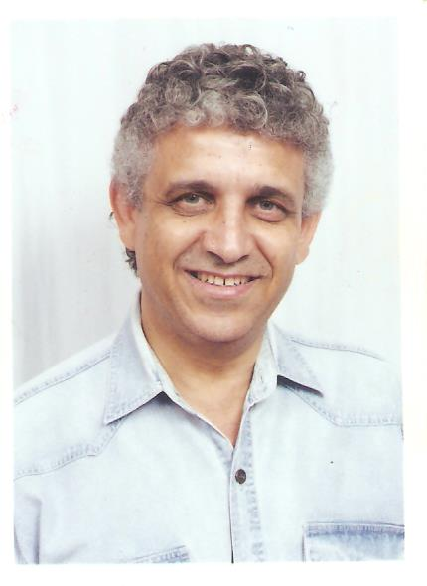

Personal
- Samir Abonil
- Canadian
- 3/4/1948
- Bachelor of Architectural science
- Arab University of Beirut 1974
- Married
- Working currently in Saudi Arabia – Khobar
- Transferable residence permit.
- +966 590865062
- samirabonil@yahoo.com
- samirabonil@gmail.com
- Looking for a management post (only), in building construction .

Work background

- Well over 35 years work experience in building construction projects.
- Managed many construction contracts in various locations in Saudi Arabia.
- Have extensive experience with working with R.C Jubail projects.
- Worked with multinational companies.
- Managed all teams in all projects and big numbers of manpower.
- Managed many contracts in the same time.
- Managed all projects planning, scheduling, quality, safety, and procurement procedures and requirements.
- Managed cost versus completion time.
- Prepared bid, contracts and costings, completely.
- Prepared bidding documents.
- High efficiency in dealing with clients, staff and work force.
- Complete familiarity with building codes, procedures and requirements.
- Handled projects up to around 250 million Saudi Riyals.
- Worked as a designer for many public building in the GCC.
- Worked in procurement of exterior and interior building material from Europe , Canada, and the U.S.

