ABRAHAM SINI ABRAHAM
: ~WhatsApp -00973 36844840, 00973 39562648 ~ 00919995197118, 9207990224
: sini_abrhm@yahoo.com
SKYP: eric.abraham4

OBJECTIVE

Seeking middle to senior level assignments in Project Management with an organization of high repute, preferably in Construction sector.

PROFILE SUMMARY

Over 21 years of experience with 2 years of entrepreneurial exposure in:
- Project Management - Construction Management - Site Management
- Manpower Planning - Team Management - Liaison & Coordination
- Quality Inspection - Quantity / Quality Surveying

Expertise in all kinds of structural Steel & Form Works (PERI, Cup lock System, Tocco Plywood Shuttering & DOKA), Concrete and Block Work like Solid, Hollow, and Form Block, etc. Holds distinction of executing prestigious projects of large magnitude within strict time schedule and cost & quality control. Successfully managed multiple projects and milestones while ensuring projects complied with all cost and scope specifications. Familiar with current international, national & client standards, procedures & specifications.

Adept in managing overall construction projects encompassing planning, monitoring, controlling phases of project lifecycle, inter-discipline coordination, administration and resource planning. Strong organizer, motivator, team player and a decisive leader with successful track record in directing from original concept through implementation to handle diverse market dynamics. Excellent relationship management, analytical and negotiation skills with deftness in swiftly ramping up projects in co-ordination with Clients, Architects, Consultants and Contractors.

ORGANIZATIONAL EXPERIENCE
Presently Working in M A Y Al Mezeal Contracting as Site Agent
From 14/10/2017 400 Nos Type D11, Houses, for MOH, at Ramli.
June’16 – Sep’17 Honesty Contracting as Project Manager

July’14 – June 16 Almoayyed Contracting Group. As Sr. Project Engineer
Jun’12-Jun’14 Al-Qawareer Contracting Co., As Project Manager
Sep’07-Aug’09: Al Futtaim Carillion, As Sub-Agent
Nov’04-Aug’07: Al Hamra Construction Company, (Sister Concern to RAK Ceramics) As Project Engineer
Oct’97-Oct’04 Al Nasar Contracting company. As Project Engineer
Key Result Areas:

- Spearheading activities involving working out various requirements & monitoring overall project operations for ensuring timely completion
- Monitoring activity at sites, reviewing schedules, estimating & costing within budget, planning for cash flow requirements, etc.
- Devising inspection requests, non-conformance reports, schedules, bar charts and sub-contractor’s bills
- Anchoring on-site construction activities to ensure completion of project within time & cost parameters and effective resource utilisation to maximise the output
- Inspecting field sites to observe and evaluate condition, operability of facilities & structures and collecting field survey data & measurements
- Formulating & implementing stringent systems and quality plans / manuals to ensure high quality standards during all the stages of project
- Scrutinizing various site activities / work proceeds and suggesting remedies for mitigating risks involved
- Reviewing shop drawing and schedule & ensuring that all activities are carried out as per requirements of construction specifications

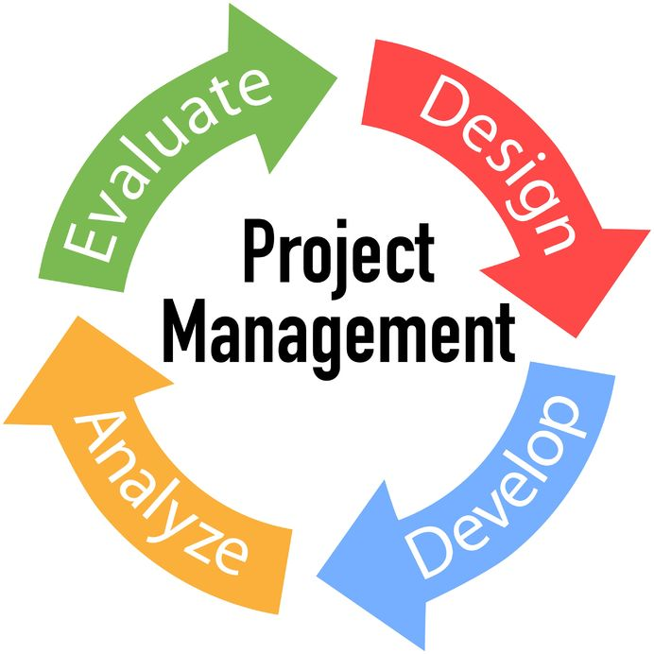

PREVIOUS EXPERIENCE
At Almoayyed Contracting Group
Title: 581 No’s G+2 Villas at AMAS
Client: Ministry of Housing, Kingdom of Bahrain
Consultant: Ansari Engineering Services
At Al-Qawareer Contracting Co.
Title: 22 Nos. Town Houses at Howrat Sanad
Client: Ministry of Housing, Kingdom of Bahrain
Title B+G+4 Building
Consultant MSCEB
Client Zayani Motors
At Al Futtaim Carillion, location as Sub Agent
Title: Dubai Motor City
Client: Union Properties
Consultants: Edara & Burt Hill

Title: Two Buildings of 2800 m² of Level 2B + G + 3

Title: One Semi Circular Building of 5400 m² of Level 2B + G + 5

Title: Emirates Aluminium Factory, Abu Dhabi
Consultant: SNC-Lavalin & Worley Parsons

Al Hamra Construction Company,
Title: Al Hamra Village
Buildings Handled: 76 Nos. of Duplex Villas
Cost: DHS 300millions

At Al Nasar Building Contracting
Title: Commercial & Residential Buildings

Title: Villas for Sh. Zayed Housing Program

Title: Villas for Government of Sharjah

At Puthuchira Constructions, Kerala
Title: School Building at Mavelikkara

ENTREPRENEURIAL EXPERIENCE

Jan’10-Dec’11: New Tech consultancy, Kerala as Project Manager

EDUCATION

1996 B.E. (Civil Engineering) from MVJCE, Bangalore University, Bangalore

IT Skills: Well versed with CAD & MS Office.

PERSONAL DETAILS

Date of Birth: 20th Jun’1972
Languages Known: English, Hindi, Malayalam, Tamil, Kannada and Arabic
Permanent Address: Thekkumootil House, Vallamkulam West P.O., Tiruvalla, Pathanamthitta D.T., Kerala-689541
License Details: Holding Bahrain Driving License

