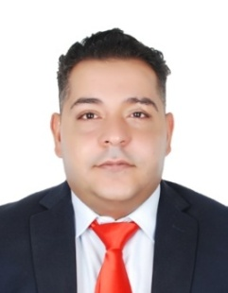
Name:Yusuf Ebrahim Salman
Nationality: Bahraini
Date of birth: 17 July 1985
Marital status: single
CPR: 850709857
Address: Bahrain-Hamed town
Mobile: 973-33660738
E-mail: y_3232550@live.com

CAREER OBJECTIVE

A dedicated driven senior with a successful background and achievement in the travel, Airlines, tourism and aviation.
Experienced with more than six years working with leading international organizations focusing on exceeding expectations for VIP high profile customer delivery ensuring Possesses excellent interpersonal, communication, business development and the ability to develop and maintain mutually beneficial internal and external relationships. Enjoys being part of, as well as managing, motivating and training, a successful and productive team, and thrives in highly pressurized and challenging working environments.

Work experience
Company Name Position Duration

- Bahrain Mumtalakat Holdings Company Air product manager 2015-2016
- American Express Bahrain Travel account manager 2014-2015
- Sky aviation Bahrain Operation officer 2013-2014
- Leaders institute Bahrain Business development 2010-2012
- Abu Dhabi Airports company Airport services Supervisor 2008-2009
- Qatar Airways Airport agent 2007-2008
- Abu Dhabi sky Holidays Travel and reservations officer 2006-2007

Education and qualification
University /College/ High school Duration

- Sunway University of Malaysia 2004-2005
- Inllingua languages college Germany 2003-2004
- Abu Dhabi secondary school 2002-2003

Trainings and workshops
Training /course / Certificate Duration

Sabre air conversion - Bahrain 2014
Mastering Retail selling 2012
Customer service with emotional intelligence 2012
Team building experiential learning 2012
Working ethics 2010
Sales techniques 2010
Safety in the work place 2010
Product awareness -Qatar Airways 2008
Basic air reservation-Sabre 2006
Ticketing and pricing-Sabre 2006
Basic functionality course- AMADEUS 2006

Skills

- Customer service
- Sales
- Operations
- Project management
- Problem solving
- Leadership
- Communication
- Ability to work under pressure
- Computer litrate
- Time managemen

Languages

- Arabic -Fluent
- English -Fluent
- German -Fluent
- French -Basic

hobbies

Traveling , reading ,surrfeing the net and flight simulator .

I therefore certify that above information is correct and true to the best of my knowledge and ability.
Signature

