Can BOLKAN (CIVIL ENG, MBA NY/ USA, PRINCE 2)
E-mail: can.bolkan@yahoo.com
GSM: +90 530 973 96 02
Istanbul, Turkey

SUMMARY…
Design, Execution ,Planning &Scheduling ,Estimation ,Procurement &Contract Management@ EPC projects, ,(I am Chartered Civil Engineer with MBA degree and western educated):Experienced Professional of 20 years of Varied Work Experience(Mixed-used construction : Heavy Civil Work Packages, Rough Work Packages, Finishing Work Packages (Fit –Out),Renovation ,Cladding &Infrastructural Works) with International Exposure of working with Contractors, Architects, Designers, Project Management Consultants , Real Estate Developers and Clients on Villas, Residential Tower, Skyscraper , Shopping Malls,7* Hotel, Hospitals &Aviation Projects.
PROJECT/CONSTRUCTİON MANAGEMENT:In depth experience on FIDIC Red
- Extensive experience in several fast tracks, high profile mega projects across all project lifecycle phases from conceptual design to final handover and project close-out.
- Unique blend of experience in site project management, construction management, technical office management and design development with main contracting companies, project management consultants and design consultants.
- Technical expertise in managing conceptual designs, detailed designs, pre-construction review, shop & coordination drawings, technical submittals and providing comprehensive support to project stakeholders.
- Proven record of accomplishment of managing fast track assignment and ensuring achievement of all milestones, deadlines, budget, scope, quality and HSE objectives.
- Planning ,directing, supervising and controlling the execution of all business, technical, fiscal and administrative functions of the assigned project or subtasks,*Develop Schedules and plan for variances of the project,*Monitoring and reporting to the Management on the progress of all the project activity within the program,*including significant milestone and conditions which affect project progress payments/cost,*Managing of Engineering /Construction/Supervision team during construction phases and provide oversight for infrastructure /structural / Architectural and MEP ,interior fit -out external works and procurement ,installation of all FF&E and other elements required to satisfy the Client requirements .
- Value Engineering and Lean Management knowledge on Construction, *Project Time/Cost/Stakeholder/Configuration/Quality /Design and Interface Management skills
Oracle Primavera Software, Delay Analysis (for EoT), Data Mining, What-if Analysis, Schedule Mitigation, Dispute Resolution, Change Order Negotiation, Verify Payment Lean *Scheduling /Pull Planning, Time Impact Analysis (TIA), Tender and construction master program, Detailed working program, Critical path analysis…

QUALIFICATIONS…
#Education:
- State University of New York, At Albany University, Master of Business Administration, MBA General,2009-2011.
- Eskisehir Osman Gazi University, Civil Architectural Faculty, Civil Engineering, 2000 – 2004.
- British Columbia Institute of Technology, Architectural &Building Design ,1996-1999
#Certificates:
- PRINCE 2 Agile in Project Management issued by PEOPLECERT in 2018, with GR650000363AF1 Certificate Number.
- Fundamentals in Construction Project Management in London /UK, by University of Salford Online at Robert Kennedy College.
- PRINCE 2 Foundation Certificate in Project Management issued by APMG International in 2019 with 04041361-0103J9D License Number
- Quality Engineering issued by American Society for Quality Engineering department in 2014 with 28149 License number.
- Primavera Professional Certificate issued by 3D line in Istanbul in 2008.
- Contract and Claim Management issued by ISC Consulting (New York based Engineering &Consulting firm) in 2017.
- ISO 9001 2008 Quality Management issued in 2013 by BSI Turkey, with 13485 License number.
- Tilos issued by FDN Future Development in 2015, with 1205-071510 License number
- LEED (The Lead green building rating system) issued by AML Office in 2016, in USA
- Certificate of Management (Lean Construction) issued by AGM of America on January 25,2019
#Languages:
- English (Native or bilingual proficiency),
- Turkish (Native),
- German (Advanced),
- Russian (Elementary proficiency),
- Arabic (Intermediate proficiency)
#Computer skills:
- MS Office (Excel, Word, PowerPoint, Visio),
- AutoCAD Revit, Navisworks, Bim applications
- MS Project, Primavera, Tilos
#Soft /Technical skills:
- Client-focused. Strong leadership and management skills, Strong organizational, interpersonal, and communication skills, Solid experience managing major capital building programs and projects, Excellent analytical skills, problem-solving skills, Excellent, culturally appropriate, verbal and written communication skills, Agile, flexible and responsive to changing demands. Forward-thinking, Strong initiative, Ability to work under pressure. Ability to interface with key internal and external stakeholders at an Executive level…

WORK EXPERIENCE:
1-Project Manager at Arup Engineering
Istanbul /Turkey(Jan 2016 –Present)
Project Name: Istanbul Grand (3rd) Airport
Project Type:Transportation(Aviation)
Project Value:£12Billion
Project Scope: 4 Terminal Building(Domestic and International),Yotel(5*) hotel with 446 rooms with smart technology,32.000sqm food&Beverage area,100.000sqm shops and Resturants,143 passenger boarding bridge,4 Traffic Control Tower(in 80 m height),2.000,000,00 sqm interior finishing works,1.500,000,00 m3 concrete,500,000,00 ton Structural steel,Parking buildings , Viaducts ,Aircraft hangars,Workshops,offices,Squadron buidings,Runway, Support facilities associated extrenal works and Landscaping Works.
Key Responsibilities:

- Manage Tenders, Design management, Prepare procurement strategy,
- Manage Estimation, Cash Flow and Budget,
- Manage Contracts and Project schedule,
- Reports on Time Entitlement Claims, Prepare and submit progress reports,
- Prepare the execution plan and procedures, Manage conclusion of construction contracts,
- Chair project team meetings with third parties, Manage value engineering and risk evaluation,
- Prepare overall design / construction schedule, Monitor actual progress against planned progress,
- Prepare progress monitoring tools for the management and monitoring of the schedules,
- Prepare and agree project control procedures during the design and construction phases,
- Monitor design progress (flow of information from Local sub consultants to Prime designer)
- Establish and agree project reporting procedures, prepare and present monthly project progress to client,
- Etc.

2-Construction Manager at Torunlar Real Estate &Development
Istanbul/Turkey (Jan 2013–Jan 2016)
Project Name:Mall of Istanbul
Project Type:Retail ,Residential , * Hilton and Hospital
Structural Type:Structural Steel&Concrete (Mixed use)
Project Value:Approx.$ 500 Millions.
Project Location:Istanbul/Turkey
Project Scope: 300,000m² GLA retail and leisure complex over three levels, with 600 shops, 100 F&B units, a 30-screen multiplex including an IMAX screen, 10,000 car parking spaces, and a 5-star, 210-bed luxury hotel operated by HİLTON,29 Story Residential buildings.
Key Responsibilities;
- Performs on-site management, supervision and coordination of all self-performed and contracted work,
- Ensures execution of field construction activities in conformance with project drawings, specifications, schedules, cost estimates, procedures, quality requirements and safety standards,
- Controls project schedule and cost through the efficient use of all construction resources and contractors,
- Oversees the development of project schedules in cooperation with the construction engineers and contractors.
- Reviews design scope and approach regarding constructability and submits recommendations for change,
- Determines manpower levels to attain schedule milestones and monitors manpower levels and craft mixes to ensure conformance with the construction plan,
- Monitors productivity and cost and implements appropriate action to maintain maximum labor productivity and cost-effectiveness,
- Controls change/scope creep, ensuring that all scope changes are quickly and properly documented and that change orders are approved prior to the performance of work,
- Manages the contractual commitments of contractors, including cost, quality, and schedule and coordinates their field activities…
Some Perspective from the Project…
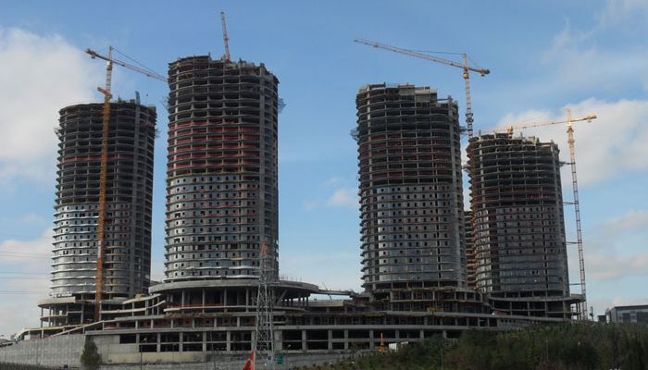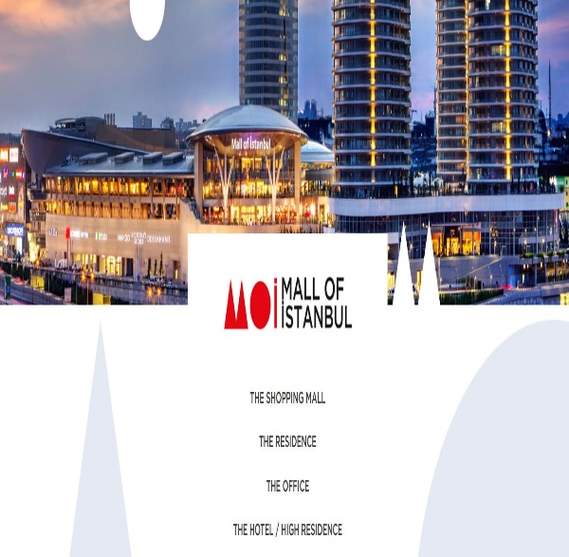

3-Construction Manager at UCC Con Trading &Contracting
Doha ,Qatar (Feb 2010 –Jan 2013)
Project Name:Mall of QATAR
Project TypeCommercial&5* Hilton
Structural Type:Structural Steel&Concrete (Mixed use)
Project Value:Approx.$400 Millions.
Project Location:Doda/Qatar
Project Scope: 256,000m² GLA retail and leisure complex over three levels, with 500 shops, 100 F&B units, a 19-screen multiplex including an IMAX screen, 7,000 car parking spaces, and a 5-star, 210-bed luxury hotel operated by Curio Collection Hilton
Key Responsibilities;
- Performs on-site management, supervision and coordination of all self-performed and contracted work,
- Ensures execution of field construction activities in conformance with project drawings, specifications, schedules, cost estimates, procedures, quality requirements and safety standards,
- Controls project schedule and cost through the efficient use of all construction resources and contractors,
- Oversees the development of project schedules in cooperation with the construction engineers and contractors.
- Reviews design scope and approach regarding constructability and submits recommendations for change,
- Determines manpower levels to attain schedule milestones and monitors manpower levels and craft mixes to ensure conformance with the construction plan,
- Monitors productivity and cost and implements appropriate action to maintain maximum labor productivity and cost-effectiveness,
- Controls change/scope creep, ensuring that all scope changes are quickly and properly documented and that change orders are approved prior to the performance of work,
- Manages the contractual commitments of contractors, including cost, quality, and schedule and coordinates their field activities…
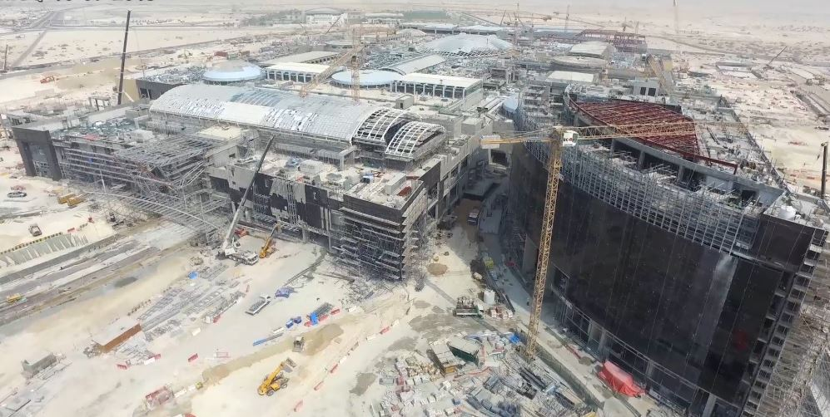

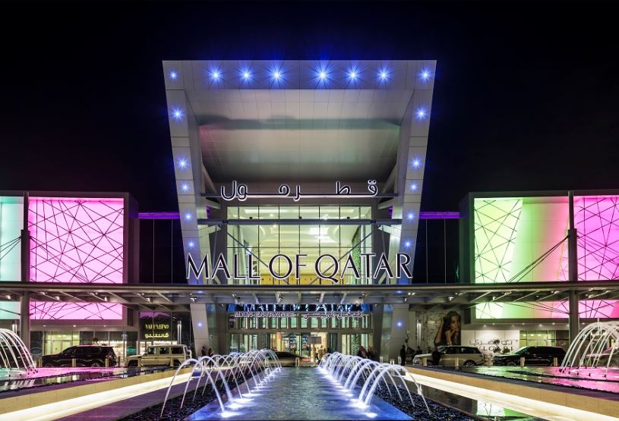

4-Deputy Construction Manager at Turner, May 2006-Feb 2010
Dubai ,United Arap Emirates ,
Projects Name: Burj Khalifa
Project Type:Office ,Residential and 7 * Hotel Armani
Structural Type:Mixed Use(Concrete&Structural Steel,Skyscraper)
Project Value:$1.5 Billion USD.
Project Location: Downtown Dubai, Dubai, United Arab Emirates
Project Scope:Construction of tallest(828m) man made building over the earth,163 story ,330.000 m3 concrete &39.000 ton rebar,4.000.000,00 sqm.
Armani hotel (*******) and Sky-Residence
Key Responsibilities:
- Plan, organize and direct Sub- Contractors, manage contract scope and execution methodology,
- Review project documents (drawings, specifications, RFI’s, schedules, etc.) and evaluate the completeness for the respective phase of design and/or construction,
- Managing the quality of the project(s) and manage facility to ensure successful completion as it relates to “on time” and within budget,
- Prepare overall project schedule to measure contractor’s schedule performance Managing of Engineering /Construction/Supervision team during construction phases and provide oversight for infrastructure /structural / Architectural and MEP, interior fit -out external works and procurement, installation of all FF&E and other elements required to satisfy the Client requirements,
- Apply Value Engineering and Lean Management on entire Construction phases,
- Etc.…

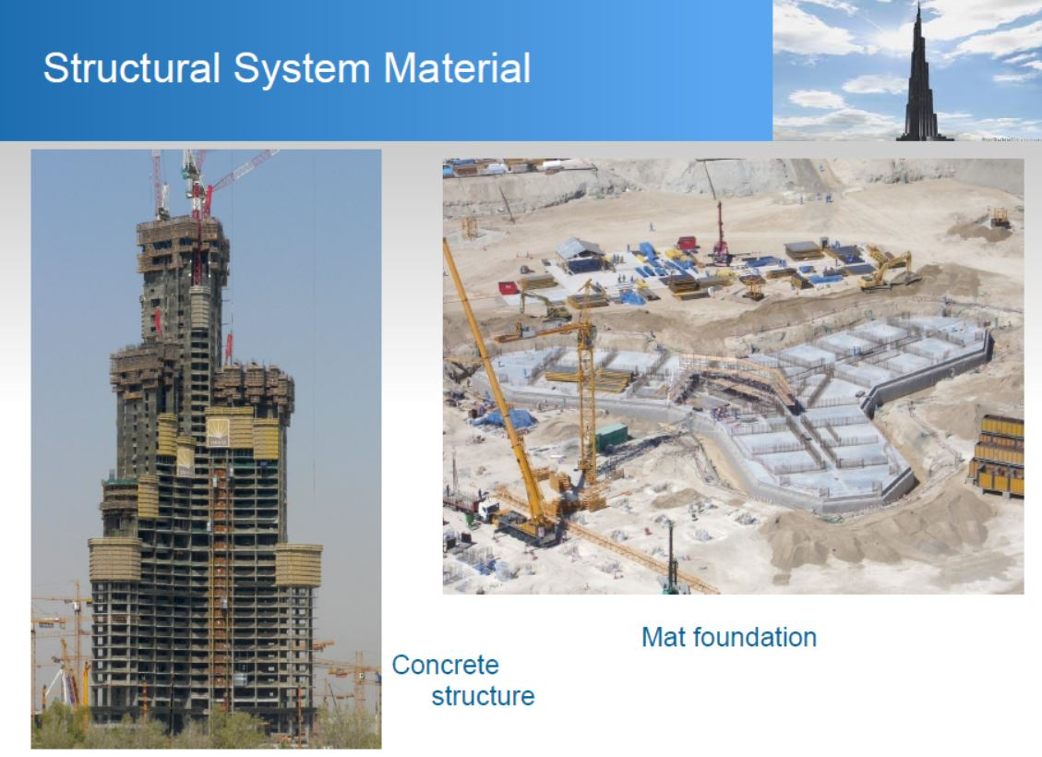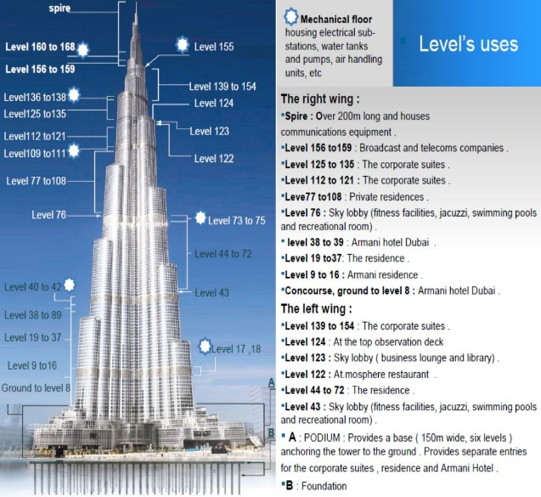

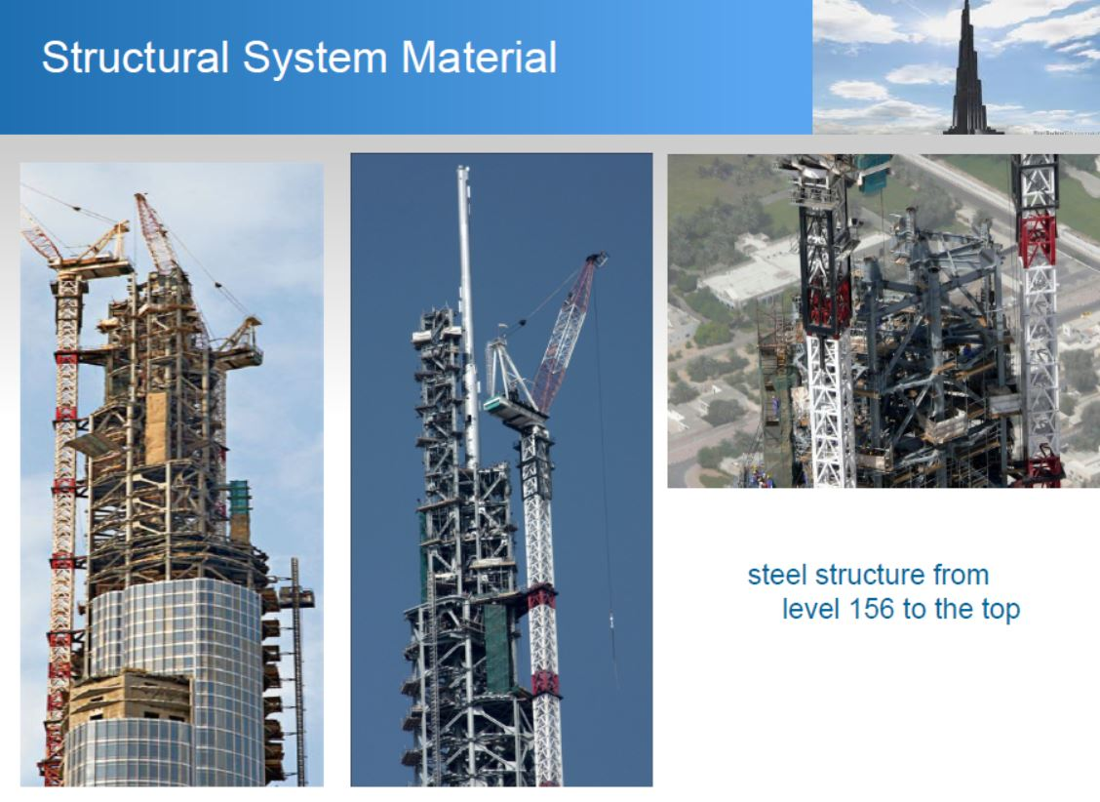

5- Project Control Manager at Aston Engineering&Contracting
Jeddah ,KSA(August 2004-April 2006),
Project Name:Jeddah Hilton Hotel (5*)
Structural Type: Mixed Use(Concrete&Structural Steel)
Project Value :$125 Million USD.
Project Scope:Construction/ renovation of 250 rooms ,2000 sqm Landscape ,artificial pond ,swimming pools ,Conference rooms and Anchillary buildings.
Key Responsibilities:
- Manage project schedule development, monitoring progress status and reporting to support Project Controls Director in ensuring in time completion of client project.
- Assist Project Control Director to set up Project Management Plans, with stage wise schedules, milestones, deliverables and timelines as per schedule management plan.
- Conduct regular project site inspections, to assess project progress, as and when required.
- Coordinate with all project parties to collate project status reports.
- Oversee and manage statistical analysis to identify schedule variances of project status against schedule baseline using EVMs and calculate Schedule Performance Index (SPI)
- Ensure that forecasts are modified which result from significant deviations from scheduled baselines.
- Monitor project schedule and implement risk management approaches as decided by Director Project Control and client.
- Analyze trends from past project reports and proactively deploy tools to prevent failures with the help of updated lesson learned documentation.
- Ensure appropriate usage and application of the Project Management System (PMS) with respect to entry and analysis of work-related data for day to day functioning to facilitate seamless communication of all relevant (technical/non-technical) information across the organization on a real time basis for maximum effectiveness.
- Interface with consultants, project team members and client for issues related to planning and scheduling activities.
- Coordinate with Director Project Control for resolution of project control issues.
- Coordinate with contracts department on issues and strategies related to variations and disputed claims.
- Attend meetings with client for all aspects of project progress.
- Advise clients on schedule variances and potential project risks and suggest and get approvals on remedial actions.
Perspective from the Project…
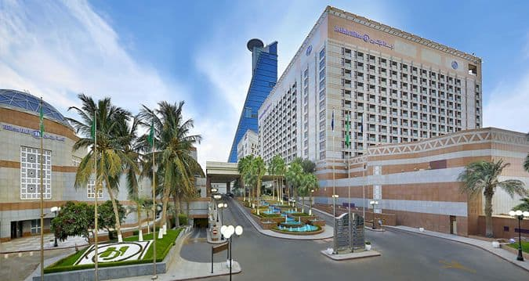
6-Planning and Cost Control Engineer at Aston Engineering Co.(August 1999-July 2004)
Project Name: Hasan Polathan Villas,Residential Buildings &Hotel
Project Type:Commercial&Residential
Structural Tpe:Mixed Use(Concrete&Structural Steel)
Project Value:$50 Millon USD
Project Scope: Residential blocks(16 Qty-16 Story),6 Story Hotel building ,44 Luxury (First Class Villa )with anchillary facilities.
Key Responsibilities:
- Planning and Scheduling,
- Cost Control and Budget,
- Contract Management…

