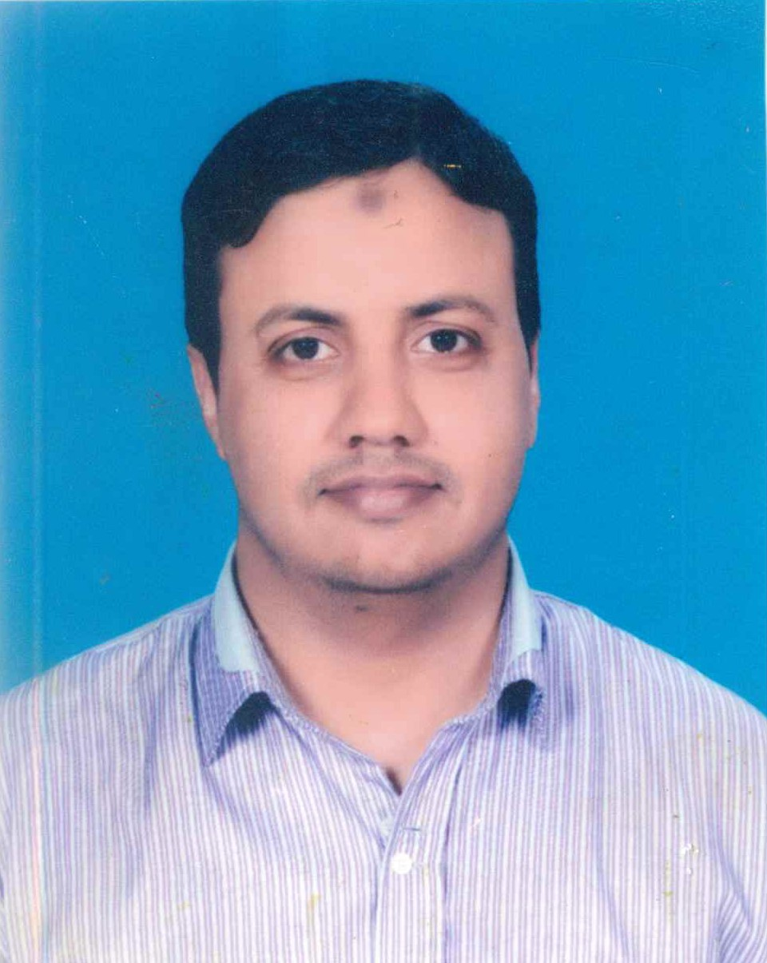

Noman Ishfaq

| ASSISTANT MANAGER FINANCE | PAYABLE | RECEIVABLE | PAYROLL SPECIALIST |

| SAP B1 | QUICK BOOK PROFESSIONAL | PGD IN HOSPITALITY AND TOURISM |

| HEALTHCARE | HOSPITAL | PATIENT CARE | HOSPITAL ADMINISTRATION |

PAKISTAN

MOBILE: 092-3214945268

[Nomaan.ishfaq@Gmail.com](mailto:Nomaan.ishfaq@Gmail.com)

**Profile**

A dedicated and results-driven finance professional with over 17 years of experience in financial management, accounts payable/receivable, audit procedures, and regulatory reporting within the healthcare, petroleum, and energy sectors. Currently serving as an Assistant Manager of Finance & Accounts at Evercare Hospital, Lahore, I excel in overseeing financial operations, managing corporate client relationships, conducting revenue collection, and preparing detailed financial reports. With a proven track record of improving financial processes, enhancing compliance with accounting standards, and driving efficiency in accounts management, I bring a deep understanding of both healthcare and energy finance.

**Experience**



**February-2022 to Date**

**Assistant Manager Finance**

Evercare Hospital

D1 Commercial, Nespak Society Phase-I, Lahore

Evercare Hospital Lahore is wholly owned by the Evercare Group (Evercare). Evercare is a global healthcare investment group and believes access to healthcare is a fundamental right for everyone. The Group invests in emerging markets to bring private, quality driven healthcare to meet the needs of local people. The Evercare Group is leading the way in transforming the traditional healthcare model through its integrated cross-continents platform, its impact driven model and quality driven hospitals.

**Responsibilities:**

* Supervise Cash Office, Admission & Discharge Office
* Supervise Revenue Collection, Manage accounts Receivable
* Managing Corporate Clients
* Patient Experience (OPD, ER management)
* support Administration manager
* Daily Contact with Banks for all receivable/collection activities
* Set objectives for the accounts receivable team that align with the accounting department’s goals
* Monitor processing of invoices, Ensure timely collection of payments
* Conduct credit checks, Negotiate with clients in non-payment cases
* Prepare monthly, quarterly, annual and ad-hoc forecasting reports
* Organize records of invoices, bills and deposits
* Ensure high-quality invoicing and collection procedures that comply with the law
* Support Accounts Receivable Clerks on a daily basis and train new team members
* Ensure all team members follow the accounting principles, Stay updated on industry and legislative changes
* Maintain accounts receivable records to ensure aging is up to date, credits and collections are applied, uncollectible amounts are accounted for, and miscellaneous differences are cleared
* Perform daily cash management duties, including the recording of bank deposits, updating and distribution of cash receipt logs, and posting of cash to the accounts receivable sub-ledger
* Monitor and collect accounts receivable by contacting clients via telephone, email, and mail.
* Prepare analytical and ratio analysis relevant to A/R so management can gain a better understanding of how collection efforts are progressing, Support other accounting and finance team members.

**June-2019 to January-2022**

**Deputy Manager Finance & Accounts:**

VITAL PETROLEUM PRIVATE LIMITED

Ground Floor, 78-D, Commercial EME-DHA, Lahore.

* Analyzing financial information and summarizing financial status
* Complete documentation and agreement of Employees Provident Fund Trust, Staff Gratuity Fund Trust, and implementation in the company
* Manage accounts Payable and Receivable process for all group entities & suppliers and customers.
* Ensure invoices & bills are paid and receipts promptly and reconcile processed work by verifying entries and company reports
* Monitor account balances & track financial activity to produce monthly financial reports
* Resolve all payables and receivables related issues with internal and external stakeholders
* Highlights the deviations from the defined Company’s policies and procedures.
* Monthly Reports, Reports to OGRA, OCAC, and Ministry of Petroleum/Energy for POL Products (All kinds of Monthly & Annual Reports as required by OGRA & OCAC)
* Attending IFEM Meeting at OGRA Office as Company representative
* IFEM Calculation, PMP, and all kinds of reports regarding IFEM
* Making of Price indent of Oil Marketing Company every month
* Supervise WH Tax Calculation, Sales Tax calculation, PRA, SRB, and working **Annex A** and **Annex C** and Reconciliation
* Complete Financial working/costing on Bulk Oil Storage Depot 10,500 MT at Hafiz Abad Khanka Doghran
* Complete Payroll/Salary Package and with Salary Tax, and TAX calculation on monthly basis.

**May-2017 to May-19**

**Assistant Manager Finance & Accounts:**

Horizon Oil Company PVT LTD.

House No: 1/B Salik Street Faiz Road Old Muslim Town Lahore.

**Responsibilities:**

* Producing & ensuring error-free accounting and financial reports and presenting their results for perfect decision for future.
* Analyzing financial information and summarizing financial status
* Ensure Timely Funds Management for Refineries and Import for Procurement of Products and smooth Hassle-Free Operations
* Controlling Banking activities timely payments and following receipts and maintaining Bank Balance
* Responsible for planning and executing the internal audit procedures to be performed.
* Highlights weaknesses/ risks associated with business processes identified during audit process & suggests mitigating controls.
* Highlights the deviations from the defined Company’s policies and procedures.
* Managing Financing Activities of the company and Being responsible for Maintaining Receivable & Vendor Ledger and reconciliations
* Monthly Reports, Reports to OGRA, OCAC, and Ministry of Petroleum/Energy for POL Products (All kinds of Monthly & Annual Reports as required by OGRA & OCAC)
* Attending IFEM Meeting at OGRA Office as Company representative
* IFEM Calculation, PMP, and all kinds of reports regarding IFEM
* Making of Price indent of Oil Marketing Company every month
* Manage foreign LC and Local LC procedure with insurance calculation as well and bridge between bank and vendors/suppliers
* Supervise complete Salary and with Salary Tax, and TAX calculation on monthly basis and yearly.

**November 2007 to April 2017**

**Senior Accountant:**

ASKAR OIL SERVICES PVT LTD.

30-A Garden Block New Garden Town Lahore.

Responsibilities:

* Overseeing and managing the accounts payable team and ensuring all invoices and expenses are processed accurately and in a timely manner.
* Maintaining accurate records of all transactions and ensuring compliance with accounting policies and procedures.
* Establishing and maintaining relationships with vendors and negotiating payment terms and discounts when appropriate.
* Preparing and reviewing monthly, quarterly, and annual reports and analysis of accounts payable activities.
* Developing and implementing policies and procedures for the accounts payable department to improve efficiency and accuracy.
* Collaborating with other departments, such as procurement and finance, to streamline processes and resolve any issues or discrepancies.
* Ensuring compliance with tax laws and regulations related to accounts payable activities.
* Managing the accounts payable budget and ensuring expenses are within the approved budget.
* Providing support to internal and external auditors during audits and ensuring all documentation is available and accurate.
* Working and implementation process in **SAP Business One** Accounting in the organization.

**Education and Qualifications**

* + Master in Commerce (M-COM)
    - Superior College Lahore, Lhr-2007
    - Attested by Higher Education Commission, UAE Embassy Pakistan & Foreign Affairs Pakistan
  + Bachelors in commerce (B-COM)
    - Scholars College, Jail Road, Lhr-2004 (Punjab University)
    - Attested by Higher Education Commission
  + Board of Intermediate & Secondary Education (Intermediate Science)
    - Scholars College, Jail Road, Lhr-2002
    - Attested by BISE
  + Board of Intermediate & Secondary Education (Matriculation Science)
    - Central model high school samanabad Lahore-2000
    - Attested by BISE

**Diploma/Certificate**

* + **Postgraduate Diploma in Hospitality & Tourism Management**
* **College of Tourism & Hotel Management (COTHM) Sep-2014 To Feb-2015**
* **CERTIFICATE IN ACCOUNTING AND FINANCE WITH PEACH TREE**

**Skills**



* **Excellent analytical and problem-solving skills**
* **Exceptional multitasking skills resulting in effective time and workload management**
* **Ability to learn and adapt quickly**
* **Problem resolution, cost reduction, Data analysis & MIS Reporting**
* **Excellent in Quick book, ERP30 and Peach Tree**
* **Good spreadsheet knowledge**
* **Good Working Knowledge in SAP Business one**
* **Accounts Receivable/Payable Management**
* **Internal Audits & Risk Mitigation**
* **Regulatory Reporting Energy Sector (OGRA, OCAC)**
* **Team Leadership & Training**
* **Stakeholder Management**